ShopWise User Guide

Contents

Overview of ShopWise 4

Introduction 4

The Shopping List (the main purpose of ShopWise) 4

The Shopping List: 5

ShopWise Terminology 6

Common Features of ShopWise 9

Main Display Options/Buttons 9

The DONE Button 9

Messages 10

Icons 11

Gestures 12

Filtering 13

Lists 14

The Main Display and it’s Options 16

The Initial Main Display when ShopWise is started for the first time. 17

The Fully Populated Main Display. 18

SHOPS 19

The Main Display (click the SHOPS button). 19

The Shops Display (no Shops) 20

Adding Shops 21

The Shops – Add Display (click ADD button from the Shops Display) 21

Adding Shops 22

Editing Shops 24

The Edit or Stock Shop dialog 25

The Shops – Edit Display 26

Deleting Shops (caution) 27

The Delete Shop Dialog (caution) 28

AISLES 29

The Main Display (if at least one Shop exists) (click the AISLES button) 29

The AISLES display 30

Adding Aisles 32

The Aisles – Add display (click the Add button from the Aisles display) 32

Adding Aisles 33

Editing Aisles 34

The Edit or Stock Aisle Dialog. 35

The Edit Aisles Display. 36

Deleting Aisles (caution) 37

The Aisle Delete Dialog 38

STORAGE 39

The Main Display (click the STORAGE button). 39

The Storage Display. 40

Adding Storage 41

The Storage – Add Display (click the ADD button from the Storage Display). 41

Adding Storage 42

Editing Storage 43

To edit a Storage click on the respective Storage in the list. This will result in a dialog appearing. You can select either CANCEL or EDIT from the dialog. 43

The Edit Storage Dialog 44

The Storage – Edit Display. 45

Deleting Storage 46

PRODUCTS 48

Products Display 49

Adding Products 50

The Storage – Add Display (click the ADD button from the Storage Display). 50

Adding Products 52

Editing Products 53

To edit a Product click on the respective Product in the list. This will result in a dialog appearing. You can select either CANCEL or EDIT or STOCK (if at least one Aisle and one Product exist) from the dialog. 53

The Edit Products Dialog 54

The Products – Edit Display. 55

Deleting Products 56

The Product Delete Dialog 57

STOCK 58

The Stock Display 60

Adding Stock via the Stock Display 61

The Stock Add Display (Click ADD from the Stock Display) 61

Adding Stock via the Shops, Aisles or Products Displays 63

Editing Stock 64

Deleting Stock 65

ORDER – Adding Adhoc Shopping List Entries 66

CHECKLIST - Adding Shopping List entries based upon what you have. 68

Shopping 70

The Shopping List (Main Display SHOPPING) 70

The Adjust Display (click ADJUST button on Shopping List) 72

RULES 74

The Rules display (click RULES from the Main display) 74

The List 75

Adding Rules 76

Adding Rules (click the ADD button from the Rules display) 76

Editing Rules (click on a Rule listed in the Rules Display) 79

Deleting Rules (long-click a Rule listed on the Rules Display) 80

Prompted Rules 81

The Prompted Rules Dialog 81

The Prompted Rules Display 82

Rule Suggestion and Rule Accuracy Checking 84

The Tools Rules display 85

Example of the Tools Rules display with the DISABLED button present. 86

Rule Suggestion (click Suggest on the Tools Rules Display) 87

The Rule Suggestion List 87

Rule Suggestion Frequency and Quantity Determination 88

Adding a Suggested Rule 89

Re-instating DISABLED Rule Suggestions (click TOOLS then RULES) 90

Rule Accuracy Checking (click CHECK on the Rules Tools Display) 91

The Rule Accuracy Check List 91

Backup and Restore (click TOOLS and then BACKUP) - caution 93

The Backup Display 93

Advanced Backup/Restore 95

Base File Name 95

Date/Time part 95

File Extension 95

# Overview of ShopWise

## Introduction

**ShopWise** is an Android **Shopping List App**, designed for **10” Tablets**, with consideration for the less technical savvy savvy user in mind. Although designed primarily for 10” tablets, **ShopWise** can be used on smaller tablets and even phones. However, the display size can then be difficult due to the reduction in size.

**ShopWise** is intended to, always be free, always be free from Advertising and always be free from your personal information being recorded and passed to other parties.

**ShopWise** is intended to offer functionality over display wizardry. **ShopWise** has no icons and bar click, long-clicks and scrolling lists, uses no gestures/ fancy finger-work.

## The Shopping List (the main purpose of ShopWise)

The prime function of **ShopWise** is to present a **Shopping List** ordered by **Shop**, then **Aisle** (location within a Shop) and then **Product**. Each level, **Shop**, **Aisle** and **Product** (more correctly **Stock**, as will be clarified later) has an order field from 1-9999 (lower order appears first).

The **Shopping List** includes a heading that details the **Total Cost** of the Items in the Shopping List, the **Amount Spent** and the **Amount Remaining to be Spent**.

A simple click (touch) of the **BOUGHT** button, that each row includes, mimics the placement (purchase) of the respective **Product** (Stock) into the **Shopping Basket**; when the quantity purchased equals the quantity ordered the relevant row in the list is checked-off.

The **ADJUST** button, allows an item to be adjusted, the quantity, price and description of the Product can be changed. Checked-off items can be unchecked by adjusting the quantity to be more than 0 conversely adjusting the quantity to 0 will check-off an item.

The **DELETE** button removes the respective row from the Shopping List without recording any purchases.

The **DONE** button returns to the Main Display (similar to using back).

The **TIDY** button removes all of the Checked-Off rows, leaving any remaining purchases for the next time.

*A brief history of purchases is kept. That is the first purchase date, the last purchase date and the total purchased are recorded for use by the Rule Suggestion and Rule Accuracy features.*

### The Shopping List:

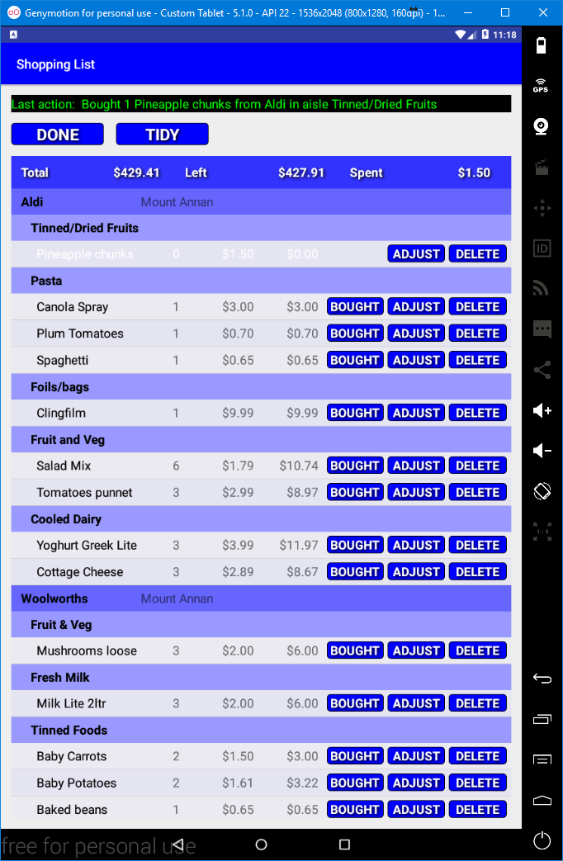

Note! **BOUGHT** button hidden when checked-off

BOUGHT, ADJUST and DELETE Buttons

A **Checked-Off Row**

(*i.e all the required quantity have been purchased*)

Row showing **Product**, quantity to get, **price** for 1 and total price.

Shop Heading (for each Shop)

Aisle Heading (for each Aisle)

**Messages**

**Totals Heading**

*The first* ***Shop*** *is Aldi, the Second Woolworths. Aldi has* ***Aisles****, Tinned/Dried Fruits, Pasta, Foil/Bags, Fruit and Veg and finally Cooled Dairy(it may have other Aisle but only those with items to buy are shown in the Shopping List). Within* ***Pasta*** *are Products, Canola Spray, Plum Tomatoes and Spaghetti. It is the respective* ***Order*** *fields that determines the sequence.*

*e.g.* ***Shop*** *Aldi has an* ***Order*** *of* ***1000****, Woolworths* ***1100*** *so* ***Aisles*** *and* ***Products*** *in Aldi are displayed before* ***Aisles*** *and P****roducts*** *in Woolworths (change Woolworths to 900 and aisles and products in Woolworths would appear before Aldi). Likewise* ***Aisles*** *have an* ***Order*** *on a per* ***Shop*** *level (Aisles are specific to a Shop). Furthermore,* ***Products*** *(actually* ***Stock*** *as will be learnt) have their own* ***Order*** *on a per* ***Aisle*** *basis.*

# ShopWise Terminology

Few would not understand what a Shop or an Aisle is. However some may be more used to using the term store for a shop and want to find something at a counter rather than an aisle. Further complications can arise as words can often have multiple meanings e.g. shop could mean a place where you can buy produce or it can mean to go and buy something. As such this section tries to clarify what terms mean when using **ShopWise**.

Generally words that are all **CAPITALS** represent an option that performs an action via a button that can be clicked.

* **SHOPS** – Where products are sold.
  + **Shops** have a name, a city (to distinguish between like name shops such as chains) and an **Order** (to determine the order in which they appear in the **Shopping List**).
* **AISLES** – A location within a shop where products can be obtained. Could **ShopWise** be used to arrange Weddings? Perhaps ☺.
  + **Aisles** have a reference to the **Shop**, a name and an **Order** (to determine the order that they appear within the **Shop** in the **Shopping List**).
  + It may not necessarily be an aisle. Some shops may only serve you from a counter where you ask where for what you want (e.g. a Deli Counter).
  + You may want to split actual Aisles into section, conversely you may wish to only have 1 **Aisle** for a **Shop**.
  + In short **ShopWise** provides flexibility.
  + At least 1 **Aisle** is required per **Shop** to be meaningful within **ShopWise** (*i.e. you can define a shop without any Aisles. However that Shop cannot then have Stock (purchasable products) and thus nothing can be ordered from such a shop*).
* **STORAGE** – A location, likely at Home, where you store products e.g. the pantry, the fridge etc.
  + A **Storage** item has a name and an **Order** (to determine the order that the **Storage** locations appear in the **CHECKLIST**).
  + **Storage** facilitates the **CHECKLIST** feature, allowing you to check what you have in an ordered fashion.
  + Again **ShopWise** is flexible, you may wish to just have a single **Storage** location, such as Home. However, at least 1 **Storage** is required.
  + Note **Storage** is often used to refer to a **Storage** location, rather than all **Storage** locations.
* **PRODUCTS** – An item that would be stored at home.
  + It should be noted that there is a distinct difference between a **Product** and **Stock**, the latter being more specifically a **Product** assigned to/located in an **Aisle** within a **Shop**.
    - A **Product** has a name, a Storage Location and a Storage Order.

**STOCK** – **Products** assigned to an **Aisle** within a **Shop** with a price/cost attached and additional values. Something that you can buy from a specific **Shop**.

* + In **ShopWise** **Stock** has different attributes than a **Product**.
    - A **Stocked** Item references an **Aisle** (*and thus implicitly a* ***Shop***).
    - A **Stocked** item also references a **Product** (*and thus implicitly the Products attributes, name, storage location and storage order*).
    - A **Stocked** item has other fields such as the first and last purchase date, the cost/price, the number purchased, an indicator to signify if it should appear in the checklist, and the quantity to check for when using the **CheckList**.
    - A **Product** can be **Stocked** multiple times. However, each has to be unique (*thus the aisle has to differ /be unique*).
  + **Stock** can be considered as a purchasable product.
* **ORDER –** Lists Stock, according to **Product name** allowing items to be added to the **Shopping List** in an ad-hoc way.
  + e.g. you may have just used a can of Baked Beans and wish to add them to the **Shopping List**.
  + Generally if the **Stock** has been marked as appearing in the **CHECKLIST** you could wait until you use the **CHECKLIST** feature. However, either way can be used.
  + **ORDER** displays a list of all **Stock**. The list includes the number already in the Shopping List.
  + The list can be filtered to quickly find the relevant **Stock** item(s).
  + **Order** (note capitalised rather than all uppercase) is also used as the name of a field for **Shops**, **Aisles**, **Stock** and **Products** for ordering lists (**Shopping List** and **Checklist**).
  + The sort order can be changed by clicking a heading.
  + Clicking a heading when already sorted by that heading, results in the sort order toggling between ascending and descending order.
  + **ADD** adds 1 of the respective item to **the Shopping List**.
  + **LESS** removes 1 of the respective item from the **Shopping List** (*note* ***LESS*** *cannot reduce the number below 0*).
* **CHECKLIST** – Lists **Stock**, set as to appear in the **Checklist**, according to **Storage location** and then **Product Order** (*sort order is fixed i.e. clicking headings will not change the sort order*).
  + The List includes the **Level** to be checked against.
    - E.g. you may wish to buy a can of baked beans if you do not have three cans at home. Thus the **level** could be set to 3.
  + **Check-Off** button checks-off an item in the list (**UNCHECK** button replaces the **Check-Off** button and the **ADD** and **LESS** buttons are hidden).
  + **ADD** adds 1 of the respective item to the **Shopping List**.
  + **LESS** removes 1 of the respective item from the **Shopping List** (*cannot reduce to below 0*).
* **SHOPPING –** Displays the Shopping List (this has been covered previously).
* **RULES –** Entries that allow regular automated or prompted additions to the **Shopping List** on a regular basis.
  + Regularity is determined by two fields a **INTERVAL** field and a **MULTIPLIER** field.
  + **Interval** is one of **DAYS**, **WEEKS**, **FORTNIGHTS**, **MONTHS**, **QUARTERS** or **YEARS**.
    - Note using Months for a day of the month that is 29-31 can be confusing due to some months not having that many days.
  + **Multiplier** is a number, an Integer. It is used in conjunction with **Interval** to produce the regularity/frequency of or prompts.
    - E.g. an **Interval** of **WEEKS** and a **Multiplier** of **3** equates to Each 3 Weeks.
  + **Prompted** Rules appear, if there are any, when **SHOPPING** is clicked.
    - Initially a **Dialog** is displayed as a reminder that **Prompted Rules** will be displayed. Clicking on **Proceed** displays the list of **Prompted Rules**.
    - **ADD** adds to the **Shopping List** and marks that occurrence as done (setting the date of the next occurrence).
    - **SKIP** skips adding that occurrence to the Shopping List and marks the occurrence as done (setting the date of the next occurrence).
    - **NOTE!** subsequent occurrences may become active and then appear in the List.
      * This would be the case if the regularity of the **Prompted Rule** is greater than the period between uses of the **Shopping List**.
      * E.g. If you setup a rule to be daily but only displayed/used the Shopping List on a weekly basis, then there would be 7 occurrences but each would appear individually only after it’s previous occurrence had been added or skipped (i.e. the date of the next occurrence is worked out only when an occurrence is actioned (added or skipped).
    - **DONE** will proceed to the **Shopping List** without either adding or skipping any of the displayed rules (so the occurrences would still be available).
      * i.e. this is an exception to the general use of **DONE** that returns to the previous display.
* **TOOLS** – Features that are complimentary to the main features of **ShopWise** or have a secondary nature of use.
  + **BACKUP** – Backup and restore of the **ShopWise Database**.
    - With careful use could be used to utilise multiple Databases.
  + **RULES** – Suggestion of Rules (**SUGGEST**) and Accuracy Checking of Rules (**CHECK**) based upon shopping history.

# Common Features of ShopWise

This section covers some of the common features or aspects used within **ShopWise** and also exceptions to the commonality.

## Main Display Options/Buttons

The primary words in the preceding list of terminology (e.g. **SHOPS**, **AISLES**, **STORAGE** etc) have been given in order that the Buttons that appear on the **Main Display** of **ShopWise** when all options are available. The **Main Display** being the options available when **ShopWise** is started and when an option and any sub options have been completed via the respective **DONE** button. The **DONE** button returns from the selected option/sub option.

* Main Display Option availability is dependent upon the data that has been input into **ShopWise**.
  + When **ShopWise** is first used and there is has been no data input only **SHOPS**, **STORAGE** and **TOOLS** options are available.
  + **AISLES** is available when at least 1 Shop has been added.
  + **PRODUCTS** requires at least 1 Storage location.
  + **STOCK** requires an Aisle and a Product and thus a Shop and a Storage location.
  + **ORDER**, **CHECKLIST** and **SHOPPING** are only available when a Stock item exists.

## The DONE Button

The **DONE** button appears on all displays with the exception of the **Main Display**. Clicking the DONE button will return to the previous **Display**, without performing any actions e.g. if changes are made but not saved and **DONE** is clicked then the changes will not be made.

* One exception is when Prompted Rules are displayed when clicking on SHOPPING and after clicking on **PROCEED** (or alternately clicking outside of the dialog which has the same affect). In this case the **DONE** button finishes the **Prompted Rules** display allowing the **Shopping List** to be displayed (any prompted rules not skipped or added will remain as they were and will be prompted for when next clicking on **SHOPPING**).

## Messages

Most displays have a message area below the display Title (the top coloured bar). Messages will be displayed here.

Messages have a black background with either green or yellow text.

Green text indicates an expected result. Yellow text indicates an issue occurred.

Displays, such as the Main display, that only have buttons for options do not have a message area.

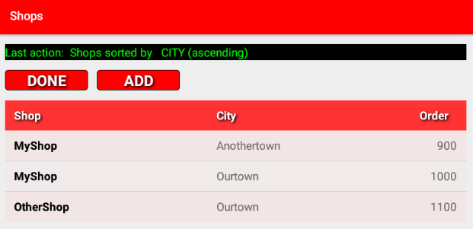

*Example of a message (from the* ***Shops*** *display, after clicking on a heading to sort the list)*

## Icons

**ShopWise** has been written with no icons as they can be confusing. However, third party offerings are outside of this remit. There is only one such known third part offering used by **ShopWise** and that is the date picker (used when adding or editing rules), this can vary according to the version of the Android Operating system in use. A custom date picker is being considered.

## Gestures

The use of gestures is purposefully kept low in order to try to concentrate on functionality rather than aesthetics. **Clicks**, **Long Clicks** and **Scrolling** are the only gestures used in **ShopWise** (*again barring third party offerings*).

* **Clicks/Clicking** – Is a short/single touch. Clicks are the most commonly used gesture. The Click gesture is used for:
  + Performing the action of a Button.
  + Selection of the relevant item from a DropDown lists (aka Spinner).
    - E.g. AISLES – ADD/EDIT has a DropDown selector for the Shop.
    - You click the DropDown selector once to display the list and then to select an item from the list.
  + Performing Edit, and where applicable Stock, actions from a list.
    - Note only primary lists i.e. not lists that are displayed as a result of selecting an item from a list.
    - e.g. if you were to click on a Shop in the list shown via SHOPS and select EDIT the list of existing Shops shown in Shops – Edit ignores clicks (and also Long Clicks).
  + Headings
* **Long Click/Clicking** – Is a touch of longer duration of about 2 seconds. However, it can be changed via accessibility options (*Touch and Hold Delay*). The Long Click gesture is used for:
  + Selecting more restrictive/sensitive actions from a List.
    - Currently only Delete actions.
    - An intermediate Dialog will display the impact of the Deletion. E.g. deleting a Shop will also require the deletion of all Aisles and thus all Stock and thus Rules, Shopping List Entries and **CheckList** entries that are used by that Shop. Products would not be deleted.
    - More information regarding the impact of Deletion is provided when discussing the Features/Options.
    - Note only applicable to primary Lists i.e. not lists that are displayed as a result of selecting an item from a list.
    - e.g. if you were to click on a Shop in the list shown via SHOPS and select EDIT the list of existing Shops shown in Shops – Edit ignores clicks (and also Long Clicks).
* **Scrolling** – Is a slide of the finger in the required direction (up or down or left or right). **ShopWise** only uses **up**/**down** scrolling. Scrolling is only applicable to lists, noting that a dialog may also be scrollable if there is more data than can be displayed at once.
  + Scrolling is limited to just changing what appears on the screen.
  + Aspects such as the appearance of the scroll bar and list top/bottom indicators are specific to the Android version.

## Filtering

Filtering is entering text in a filter than then results in the data being displayed to items that include the filter text within the respective field.

e.g. if you were to type **a** (or A filtering is case independent) then all items that have an **a** would be displayed. If you then added a **t** (filter is now **at**) then items that include **at** would be displayed and so on.

* The filter can include _ (***underscore***)as a single wild character e.g **a_t**, would include p**att**ies (**a?t**), Chicken Bre**ast**s (a?t) etc.
* The filter can include **%** as a varying length wild character e.g. **a%t** would include c**arrot**s (**a???t**).
* Some fields are implicit filters, that is they are not labelled as a filter but filter the results. e.g. The **Product** field in **Product Add/Edit** will filter the List of Products.

# Lists

ShopWise frequently utilises lists. Lists can easily be large enough to not fit on the display in which case they become scrollable (the hidden contents can be displayed by sliding the list up or down). Actions may be available from the list.

Some lists may include buttons that can be clicked, such as the **BOUGHT**, **ADJUST** and **DELETE** buttons on the **Shopping List**. Buttons reflect core actions that are expected to be used frequently. Additionally Lists may also allow actions to be invoked from a click or a long-click. Such actions are deemed as secondary and are likely to be used sparingly. If such actions are available then indicators, at the start of the row indicate. If there is a small c at the left of the row, then that indicates that the row can be clicked. If there is a small l at the left of the row, then that indicates that the row can be long-clicked. Generally a row will include neither or both. It is also likely that all rows will have the same indicators. Installation of ShopWise

# The Main Display and it’s Options

The Main Display is the display that is shown when ShopWise is started, it consists of a list of buttons.

These buttons reflect the terms that are all **CAPITALS**; **SHOPS**, **AISLES**, **STORAGE**, **PRODUCTS**, **STOCK**, **ORDER**, **CHECKLIST**, **SHOPPING**, **RULES** & **TOOLS**. However, only buttons/options that can be used are display.

The **SHOPS** button is always available.

The **AISLES** button will not be shown if there are no **Shops.** An **Aisle** must be owned by a **Shop**.

The **STORAGE** button is always available.

The **PRODUCTS** button will not be shown if there are no **Storage** locations. A **Product** must be owned by a **Storage** location.

**STOCK** will not be shown if there are either no **Aisles** or there are no **Products**. A **Stock** item must be owned by a unique combination of an **Aisle** and a **Product**. **Stock** is implicitly owned by a **Shop** due to the requirement that it is owned by an **Aisle**.

The **ORDER**, **CHECKLIST**, **SHOPPING** and **RULES** buttons will only be shown if there is at least one **Stock** (Stocked Items). An **Order** (add an ad-hoc Stock item to the **Shopping List**) cannot be made if there is no **Stock**. Nothing can be checked if there is no **Stock** (similarly **CHECKLIST** is adding **Stock** items to the **Shopping List**). If there is no **Stock** then nothing can be added to the **Shopping List**, so **SHOPPING** is unusable. If there is no **Stock** then a **Rule** cannot be set (again **Rules** are adding **Stock** to the **Shopping List**).

The **TOOLS** button is always available.

Buttons are colour coded, with the colour being used by underlying displays. e.g. the **Shops display**, shown when clicking **SHOPS** will be red. The **Shops Add display**, shown when clicking **ADD** from the **Shops display** will also follow a red theme. Likewise, clicking on **STORAGE** will result in the **Storage display** being displayed in a yellow theme and so on. Colour coding is designed to be a navigation aid.

The following two pages show the initial Main Display and the fully populated Main Display.

## The Initial Main Display when ShopWise is started for the first time.

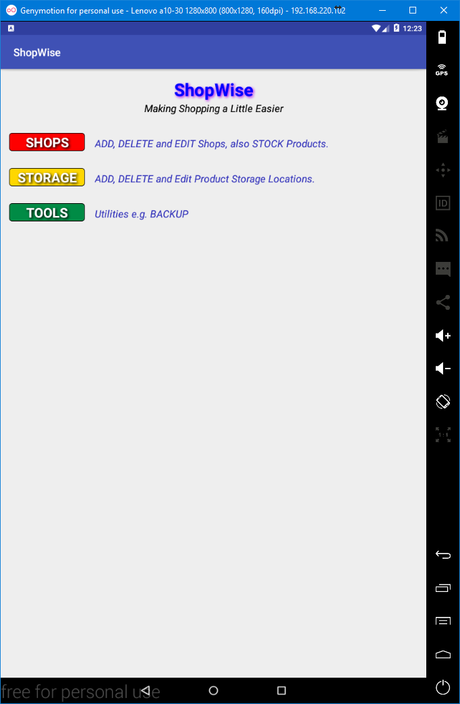

## The Fully Populated Main Display.

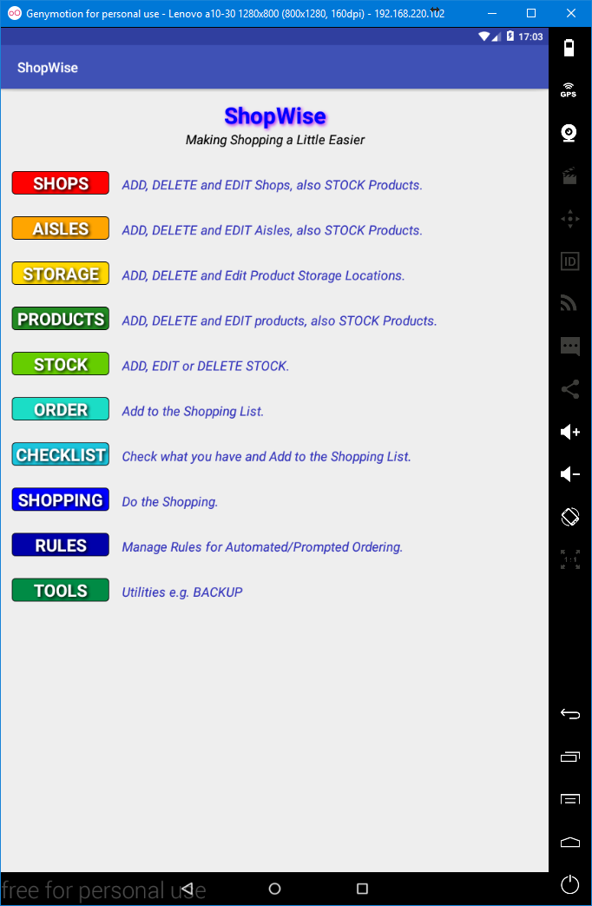

# SHOPS

## The Main Display (click the SHOPS button).



## The Shops Display (no Shops)

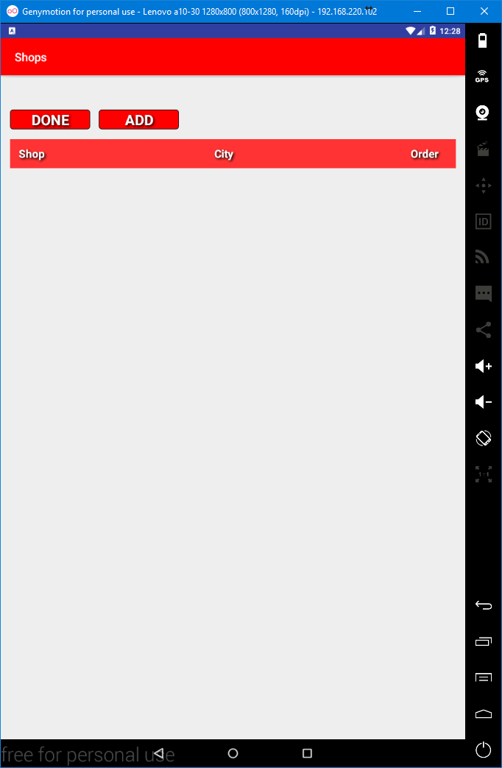

If any **Shops** exist they will be listed under the lowest red horizontal bar, the list heading (with **Shop** ... **City**... and **Order**).

Clicking a heading will sort the list according to that heading toggling between ascended and descended order e.g. clicking **Order** will sort the list according to the **Order**. Clicking list headings is standard throughout **ShopWise** with a few exceptions. The exceptions being where a fixed order is required, such as for the **ShoppingList** and the **CheckList**.

Click **DONE** to return to the **Main Display**.

Click **ADD** to add a **Shop** or **Shops**.

# Adding Shops

## The Shops – Add Display (click ADD button from the Shops Display)

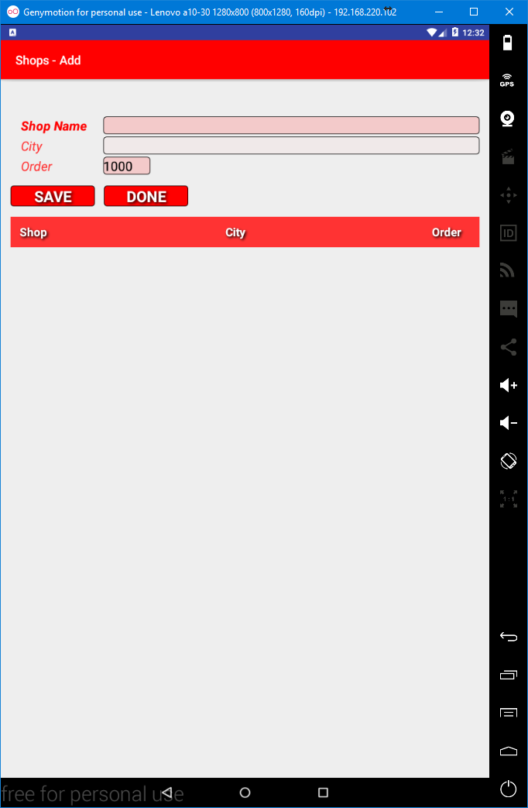

A **Shop** has 3 fields; a **Shop Name**, a **City** and an **Order**. **Shop Name** is required. Required fields have a darker background. **City** is optional. It can be used to differentiate between **Shops** with the same name e.g. chains. Optional fields have a lighter background.

**Order** is required and is suggested (i.e. it is filled in, in this case with **1000**). It must be a number between **0** and **9999**. It determines the order in which Shops appear in the Shopping List. Lower numbers appear first.

Suggestion will automatically create a number higher than the highest existing **Shop Order**, normally **100** greater. Leaving gaps between **Order** numbers gives scope for manipulation. If you input the **Shops** in the order in which you shop at them, then suggestion can make adding multiple **Shops** simpler as you can use the suggested **Order**.

## Adding Shops

To add a **Shop** enter the respective data (**Shop Name**, **City** if wanted), change the **Order** if desired and the Click on the **SAVE** button, you can also add more **Shops**.

e.g. entering:-

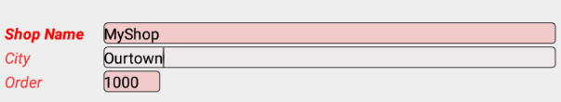

then Clicking **SAVE** :-

Added OK

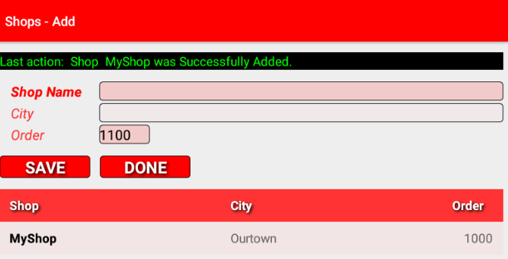

A message is displayed confirming the addition (unless an error was detected). The **Shop Name** and **City** fields are cleared, the **Order** is updated and the **Shop** now appears in the **Shop List**.

Green messages are used to indicate successful events/actions. Yellow messages indicate that an issue has arisen. E.g. If you were to click on the **SAVE** button but without providing a Shop Name then :-

Not Added

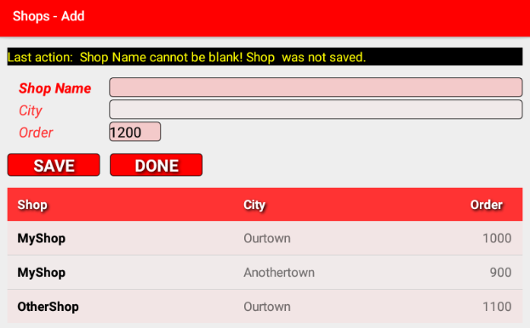

Sort by clicking a heading.

Note that a few other **Shops** have been added (clicking the list headings will sort the list, a message indicates what was sorted along with ascending or descending).

Clicking **DONE** will return to the **Shops Display**, any added **Shops** will be listed.

# Editing Shops

Editing **Shops** is accomplished from the **Shops display** which lists the **Shops**. The **Shops display** is reached by clicking on the **SHOPS** button from the **Main display**. You can reach the **Main display** by clicking the **DONE** button until it is displayed (generally either once or twice).

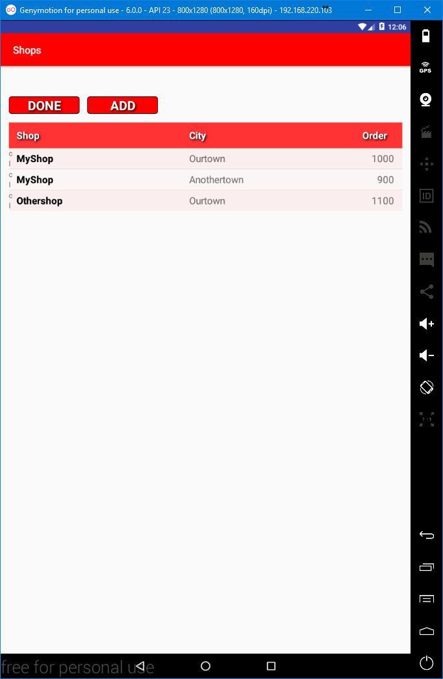

Sort by clicking a heading.

To Edit a **Shop** you click on the respective **Shop** in the list of **Shops**. This will result in a dialog appearing. This dialog allows you to select either **CANCEL** or **EDIT** or if at least one **Aisle** and at least one **Product** exists to **STOCK** via the **Shop**.

Note that in the list of Shops above that each Shop has a c and an l at the start. This indicates that the List can be clicked and also long-clicked. An absence of the c indicates that clicking the row will not result in an action. An absence of the l indicates that long-clicking the row will not result in an action.

## The Edit or Stock Shop dialog

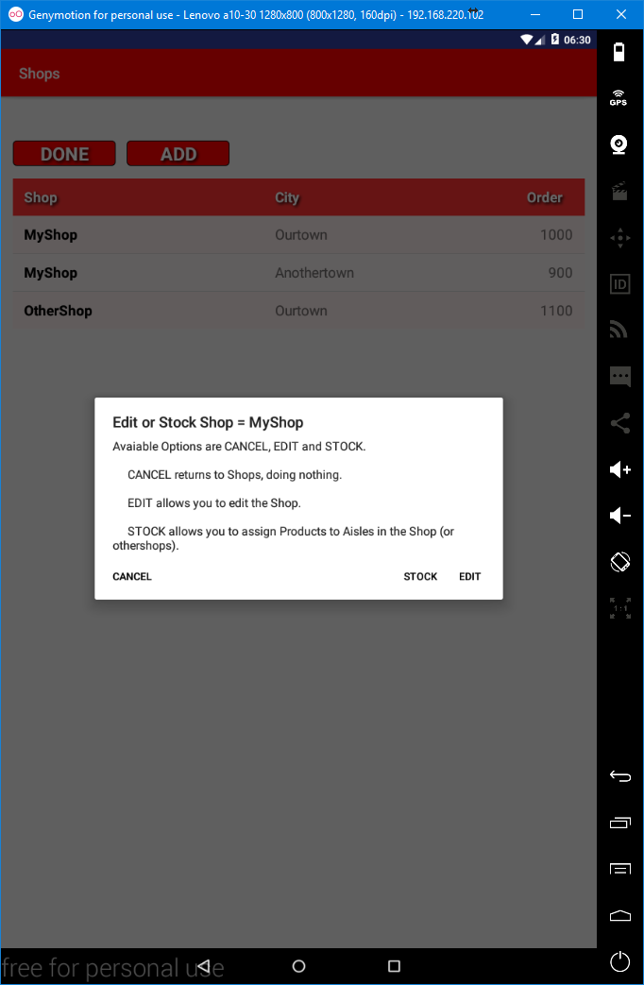

**STOCK** will be dealt with later (*note* ***STOCK*** *will only appear if at least one* ***Aisle*** *and at least one* ***Product*** *exist*).

**CANCEL** will return to the **Shops display**, doing nothing.

**EDIT** takes you to the **Shops - Edit display**.

Clicking outside of the dialog, in the greyed out area is the same as clicking the **CANCEL** button.

## The Shops – Edit Display

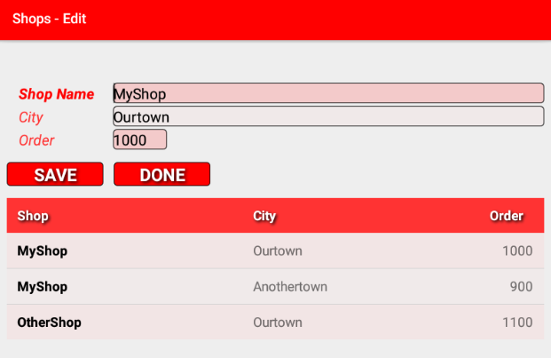

This display is identical to the **Shops – Add display** other than the data has been supplied.

The **Shop Name**, **City** and **Order** can be changed as required.

Changes will only be applied when **SAVE** is clicked.

Clicking on a **Shop** in the list does nothing.

Clicking a **Heading** will sort the list according to the header and toggle between ascending and descending order. Initially clicking a heading will, unless already sorted by the field, sort in ascending order. A message is displayed indicating the sort field and sort direction.

Clicking **DONE** will return to the **Shops display**.

Note that the list of **Shops** does not have either **c** or **l** before the **Shop**, this indicates that clicking or long-clicking a row has no affect.

# Deleting Shops (caution)

Deleting **Shops** is accomplished from the **Shops display** which lists the **Shops**. The **Shops display** is reached by clicking on the **SHOPS** button from the **Main display**. You can reach the **Main display** by clicking the **DONE** button until it is displayed (generally either once or twice).



Sort by clicking a heading.

To Delete a **Shop** you long-click on the respective **Shop** in the list of **Shops**. This will result in a dialog appearing. This dialog allows you to select either **CANCEL** or **DELETE**.

## The Delete Shop Dialog (caution)

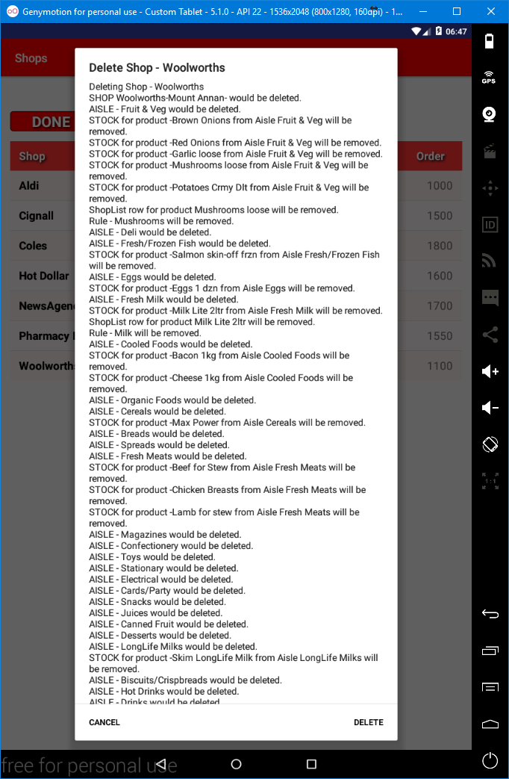

Click to CANCEL.

Click to DELETE the Shop.

The dialog provides the **impact** that **deleting** a **Shop** will have. In the case above the **impact** is quite substantial (*the list of impacts above is larger than the display and is thus scrollable*).

**Deleting** a **Shop** will **delete all** **Aisles** owned by that **Shop**, it will also therefore **delete all Stock** (not the Products) used by the **Aisles**. Deletion of any **Stock** will require deletion of any **Shopping List entries** and any **Rules** that use the **Stocked Items**.

**In short, deleting a Shop can have an extensive impact.**

Clicking **DELETE** will delete the Shop (it is suggested that you backup the data before deleting a Shop, see TOOLS – BACKUP)

Clicking **CANCEL** will return to the **Shops** display doing nothing.

# AISLES

## The Main Display (if at least one Shop exists) (click the AISLES button)

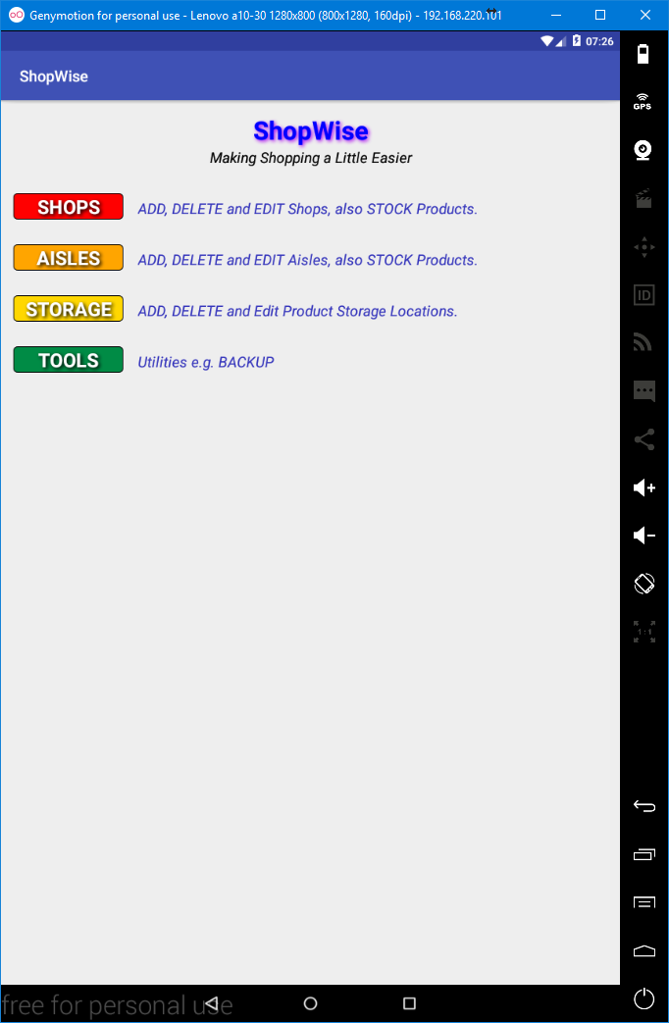

## The AISLES display

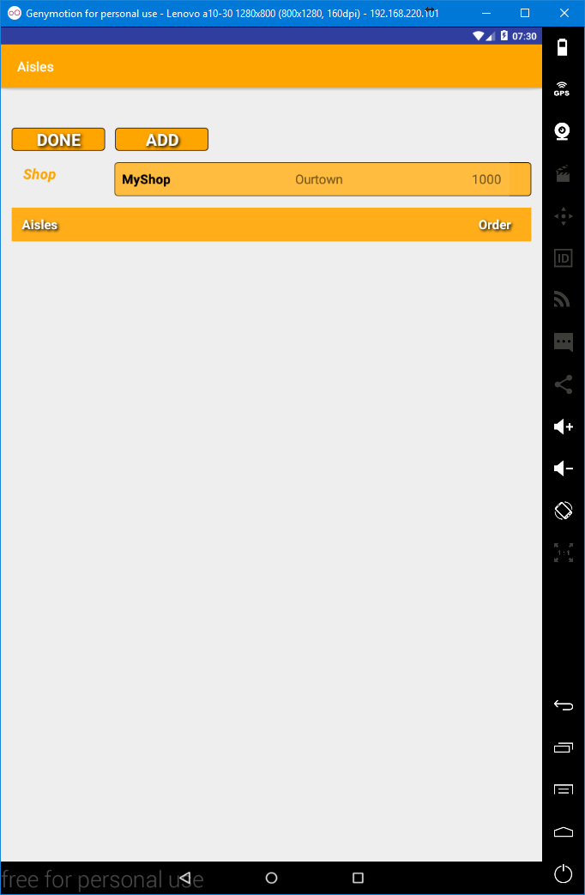

This display will display the **Aisles** that exist for the selected **Shop**, if any.

You can change the **Shop** by clicking on the **Shop** **Dropdown selector** (spinner) and then clicking on the required **Shop** from the **DropDown** list. Clicking outside of the list results in the selected **Shop** not changing and the **DropDown** list closing.

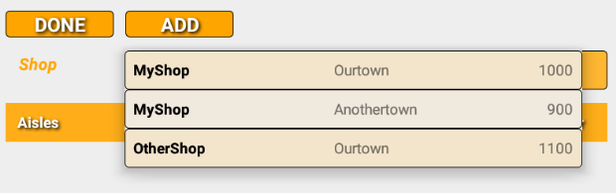

The list of **Aisles** can be sorted by clicking on the list headings (**Aisle** or **Order**).

Clicking on the same heading toggles the sort between ascending and descending.

A message indicates the sort order, what the list has been sorted on and whether the sort is an ascending or descending order.

e.g. :

Sort order message

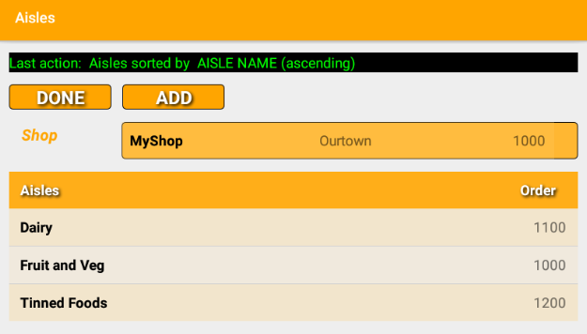

Click **DONE** to return to the **Main display**.

Click **ADD** to go to the **Aisles- Add display** to add an **Aisle** or **Aisles**. The selected **Shop** will be set as the selected **Shop** in the **Aisles – Add display**. The **Shop** can be changed in the **Aisles – Add display**.

# Adding Aisles

## The Aisles – Add display (click the Add button from the Aisles display)

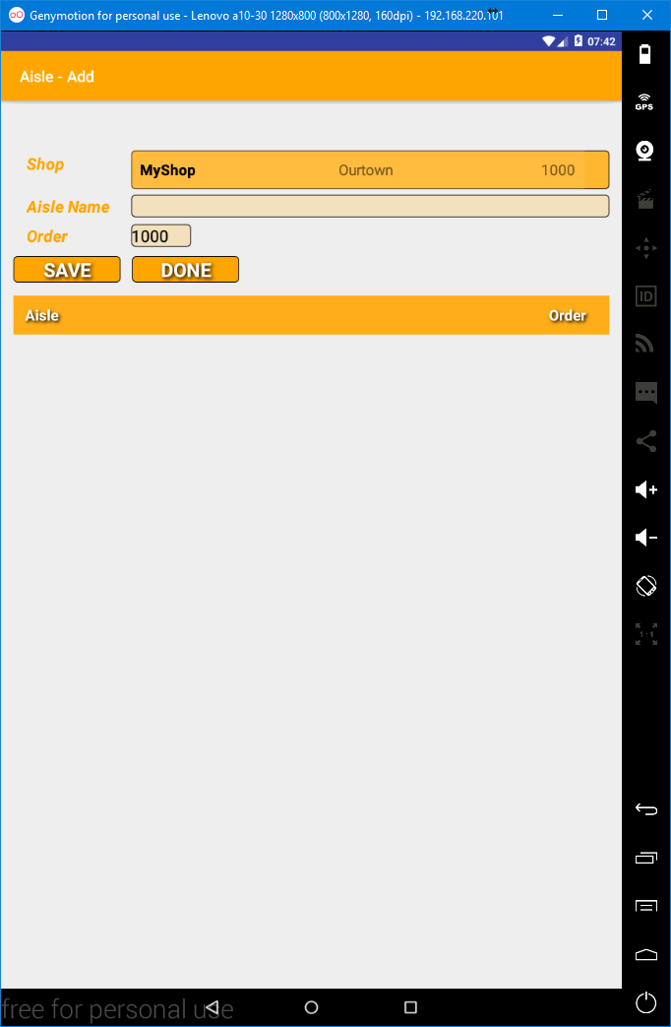

**Aisles** have three fields, **Shop** (*the* ***Shop*** *that owns the* ***Aisle***), **Aisle Name** and **Order**.

**Shop** is required and **MUST** be an existing **Shop**. The **Shop** cannot be typed, it must be selected from the **Shop DropDown selector** (spinner). You cannot not provide a **Shop**.

**Aisle Name** is required (*i.e. it cannot be blank*).

**Order** is required. It is suggested as normally being 100 higher than the highest **Aisle Order** for the **Shop.** If no **Aisles** exist for the selected **Shop** then it will be **1000**.

A list of **Aisles** that exist in the selected **Shop**, if any, is displayed. The list can be sorted by clicking on a heading. Clicking an **Aisle** in the list does nothing.

Clicking on a heading will sort the list of **Aisles**.

# Adding Aisles

To add an Aisle enter the respective data (**Shop** (selected from the **Shop DopDown selector**) and **Aisle Name**), change the **Order** if desired and the click on the **SAVE** button, you can add more **Aisles** by repeating the process.

e.g. :-

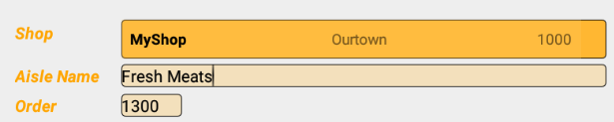

Then clicking SAVE :-

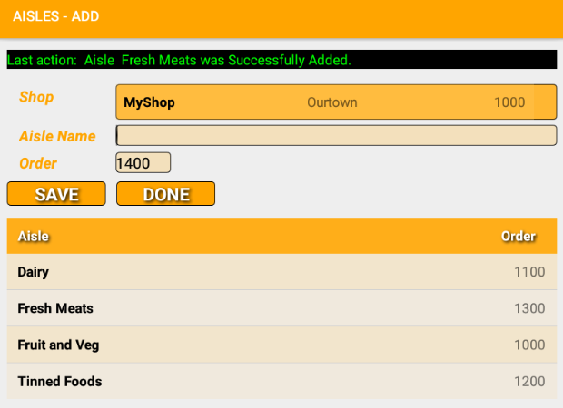

The added **Aisle** will appear in the list of **Aisles**.

You can more **Aisles** to the same Shop or to other **Shops** by selecting the respective **Shop** from the **Shop DropDown selector**.

If the **Aisle** could not be added (e.g. the **Aisle Name** was blank) then the message will be yellow and indicate the issue.

**Aisles** can have the same **Order** within the same **Shop** (not recommended). **Aisle** order is only relevant within a **Shop**, so **Aisles** from different **Shops** having the same **Order** is not an issue at all (*in fact* ***Order*** *suggestion will use* ***1000*** *as the first* ***Order*** *per* ***Shop*** *and then* ***1100*** *and so on*).

# Editing Aisles

Editing **Aisles** is accomplished from the **Aisles display** which lists the **Aisles** for a **Shop**. The **Aisles display** is reached by clicking on the **AISLES** button from the **Main display**. You can reach the **Main display** by clicking the **DONE** button until the **Main display** is shown (generally either once or twice).

The **Aisles** listed are those owned by the currently selected **Shop** as shown to the right of the **Shop** label. You should select the respective **Shop** from the **Shop DropDown selector**.

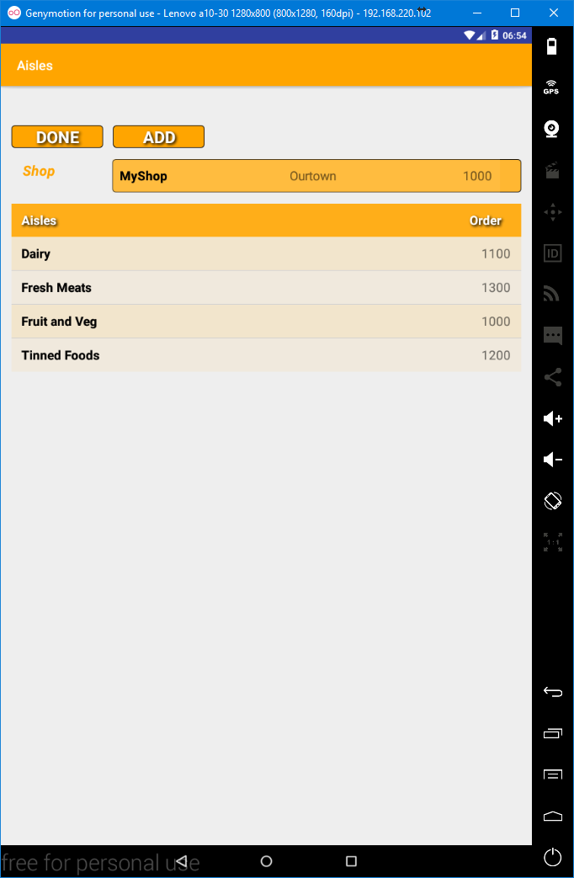

To edit an **Aisle** you click the respective **Aisle** from the list of **Aisles**. This will result in a dialog being presented. This dialog allows you to select either **CANCEL** or **EDIT** or if at least one **Aisle** and at least one **Product** exists to **STOCK** via the **Aisle**.

## The Edit or Stock Aisle Dialog.

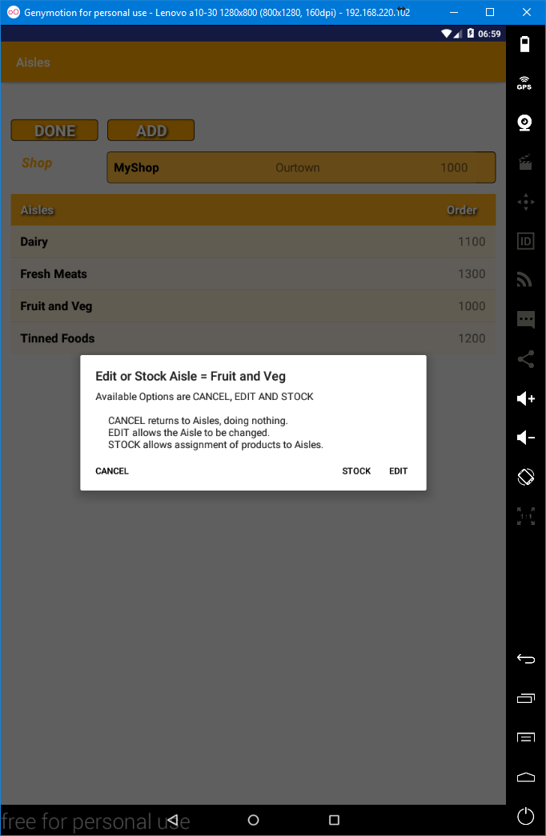

**STOCK** will be dealt with later.

**CANCEL** will return to the **Aisles display**, doing nothing.

**EDIT** takes you to the **Aisles - Edit display**.

Clicking outside of the dialog, in the greyed out area is the same as clicking the **CANCEL** button.

## The Edit Aisles Display.

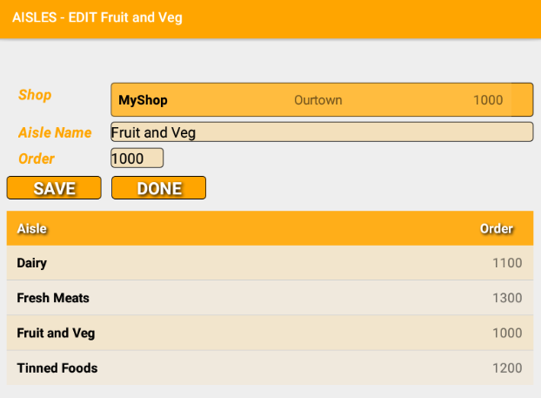

This display is identical to the **Aisles – Add display** other than the data has been supplied.

The **Shop** selector is disabled so the **Shop** cannot be changed.

The **Aisle Name** and **Order** can be changed as required.

Changes will only be applied when **SAVE** is clicked.

Clicking on an **Aisle** in the list does nothing.

Clicking DONE will return to the **Aisles display**.

# Deleting Aisles (caution)

Deleting **Aisles** is accomplished from the **Aisles display** which lists the **Aisles**. The **Aisles display** is reached by clicking on the **AISLES** button from the **Main display**. You can reach the **Main display** by clicking the **DONE** button until it is displayed (generally either once or twice).



To **Delete** an **Aisle** you long-click on the respective **Aisle** in the list of **Aisles**. This will result in a dialog appearing. This dialog allows you to select either **CANCEL** or **DELETE**.

## The Aisle Delete Dialog

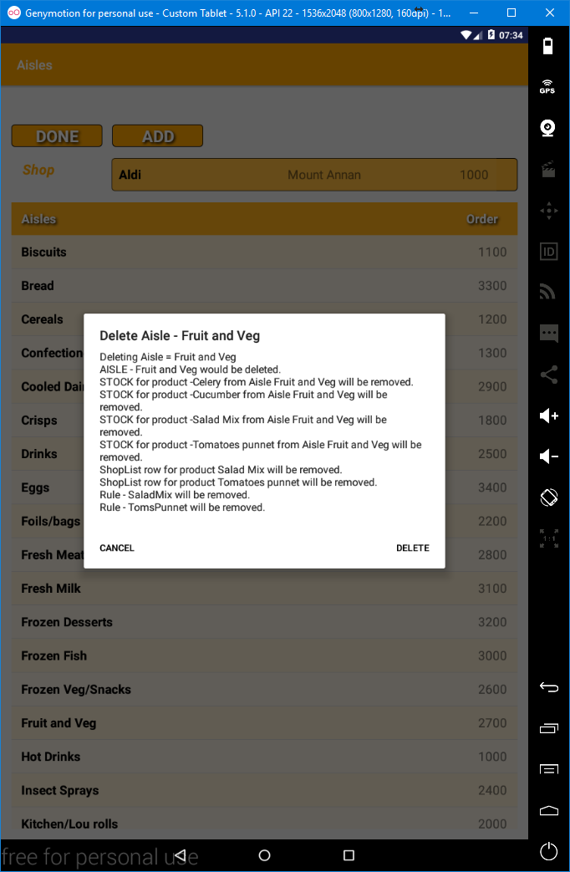

The dialog provides the **impact** that **deleting** the **Aisle** will have.

**Deleting** an **Aisle** will **delete all Stock** (not the Products) used by the **Aisle**. Deletion of any **Stock** will require deletion of any **Shopping List entries** and any **Rules** that use the **Stocked Items**.

Clicking **DELETE** will delete the Aisle.

Clicking **CANCEL** will return to the **Aisles** display doing nothing.

# STORAGE

## The Main Display (click the STORAGE button).

# 

## The Storage Display.

## 

**Storage locations** exist to compliment the **CheckList** by providing high level ordering of the **Checklist**. That is the **Checklist’s** primary sort is by **Storage location**. **Products** are assigned a **Storage** location e.g. *Butter may be assigned to the Storage location Fridge. When checking against the checklist all products with a Storage location of Fridge will be together.*

Existing **Storage** locations are listed, if any, below the list heading.

Clicking a list heading (**Storage** or **Order**) will sort the list according to the heading clicked. Clicking a heading, when already sorted according to the heading toggles the sort direction between ascending and descending.

Click **DONE** to return to the **Main display**.

Click **ADD** to add one or more **Storage locations**.

# Adding Storage

## The Storage – Add Display (click the ADD button from the Storage Display).

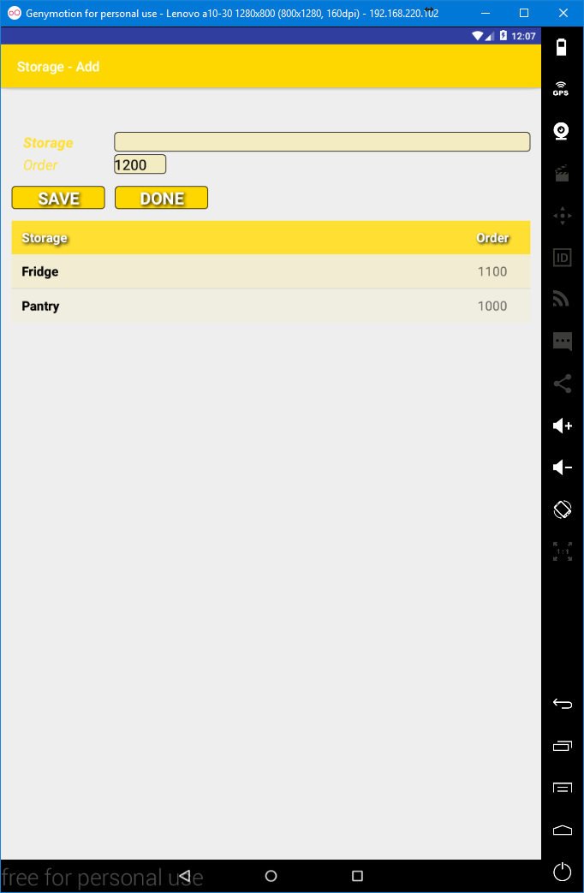

A **Storage** has 2 fields; **Storage** for the name and **Order** for the order in which the Storage location will appear in the **Checklist**. Lower **Orders** appearing first. Both fields are required. **Order** is suggested. Suggestion will be **1000** if no **Storage** locations exist and then normally **100** greater than the highest existing **Storage** **Order**.

Adding **Storage** locations in the order in which they are to be checked simplifies their addition as you don’t have to adjust the suggested **Order**.

## Adding Storage

To add a **Storage** enter the respective data (**Storage location name**) and change the **Order** if desired.

e.g.

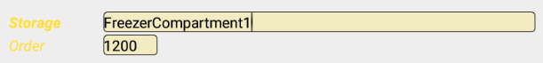

Then click on the **SAVE** button. You can repeat this to add more Storage.

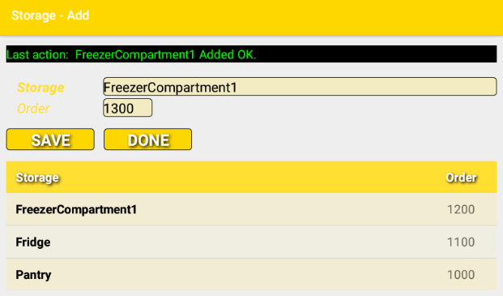

A message is displayed confirming the addition or alternately indication an issue. If an issue, such as the Storage field being blank, the message will be yellow instead of green for a successful addition.

The list will be updated with the new **Storage**.

Sort the list by clicking on a heading (**Storage** or **Order**). Clicking on a heading when the list is sorted according to the heading clicked will toggle the sort direction between ascending and descending order.

**SAVE** must be clicked to save data.

Click **DONE** to return to the **Storage display**.

# Editing Storage

Editing **Storage** is accomplished from the **Storage display** which lists the current **Storage**. The **Storage display** is reached by clicking the **STORAGE** button from the **Main display**. The **Main display** can be reached by clicking on **DONE** until the **Main display** appears.

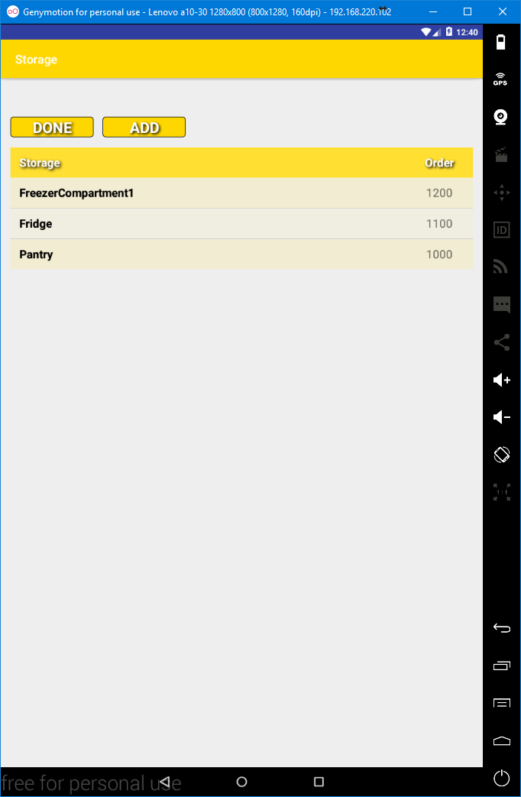

## To edit a Storage click on the respective Storage in the list. This will result in a dialog appearing. You can select either CANCEL or EDIT from the dialog.

## The Edit Storage Dialog

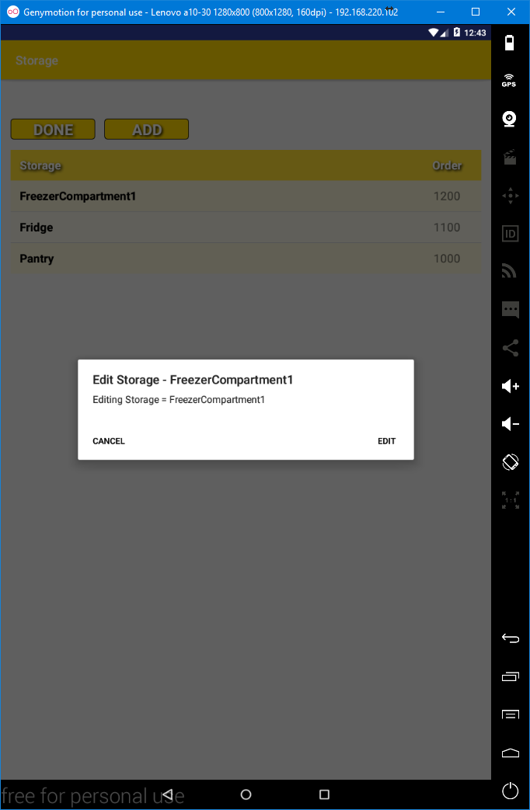

**CANCEL** will return to the **Storage display**, doing nothing.

**EDIT** takes you to the **Storage – Edit display**.

Clicking outside of the dialog (they grey area) is the same as clicking **CANCEL**.

## The Storage – Edit Display.

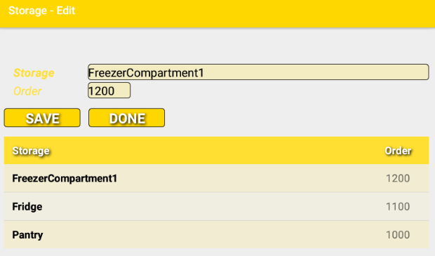

The **Storage – Edit display** is the same as the **Storage – Add display** except that the title is different and that the fields contain the data from the respective **Storage**.

The **Storage location name** and the **Order** can be changed.

Changes will only be applied if the **SAVE** button is clicked.

Clicking on a heading will sort the list of **Storage** according to the heading clicked. If the list is already sorted according to the heading clicked the sort direction will toggle between ascending and descending.

Clicking or Long-clicking on a **Storage** location in the list does nothing.

Clicking **DONE** will return to the **Storage display**.

# Deleting Storage

Deleting **Storage** is accomplished by clicking on a **Storage location** from list that in the **Storage Display**. The **Storage Display** can be reached by clicking on the **STORAGE** button from the **Main display**. The **Main display** can be reached by clicking **DONE** until the **Main display** appears.

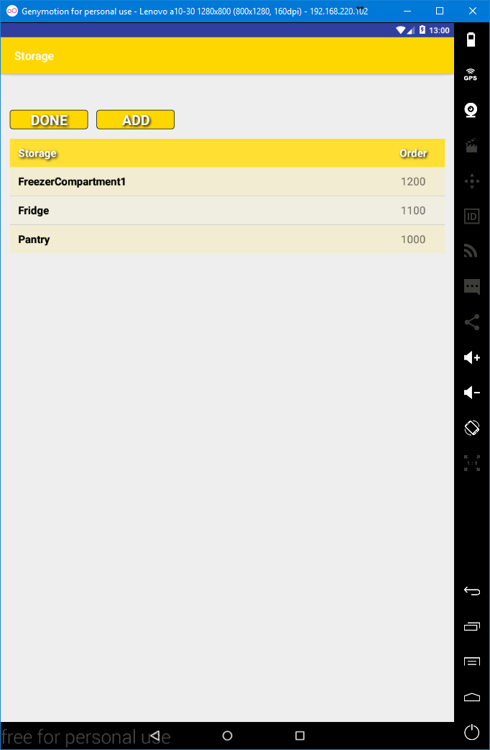

To Delete a **Storage** location long-click on the respective **Storage** location from the list. If the Storage has any products assigned then a yellow message will appear indicating that the Storage cannot be deleted because it is not empty. Otherwise a dialog will appear allowing CANCEL or DELETE to be clicked.

Clicking **DELETE** will delete the **Storage** and the **Storage display** will be shown with an updated list.

Clicking **CANCEL** will return to the **Storage display**, doing nothing.

The reason why **Storage** deletion does not allow deletion of **Storage** that has **Products** assigned, is that the deletion of **Products** could have far-reaching implications. Deleting a used **Storage** location would require that the **Products** in that **Storage** location are either moved to another Storage location or that they are deleted in order to maintain the integrity of the database. Moving **Products** to another location could be timely or inflexible. Mass deletion of **Products**, would required deletion of **Stock**, **Shopping Lists entries** and **Rules**.

As such if a **Storage** location, that has Products assigned to it, then those **Products** must be either be moved to another **Storage** location or deleted via the **Products Display** (see **PRODUCTS** below).

# PRODUCTS

## 

## Products Display

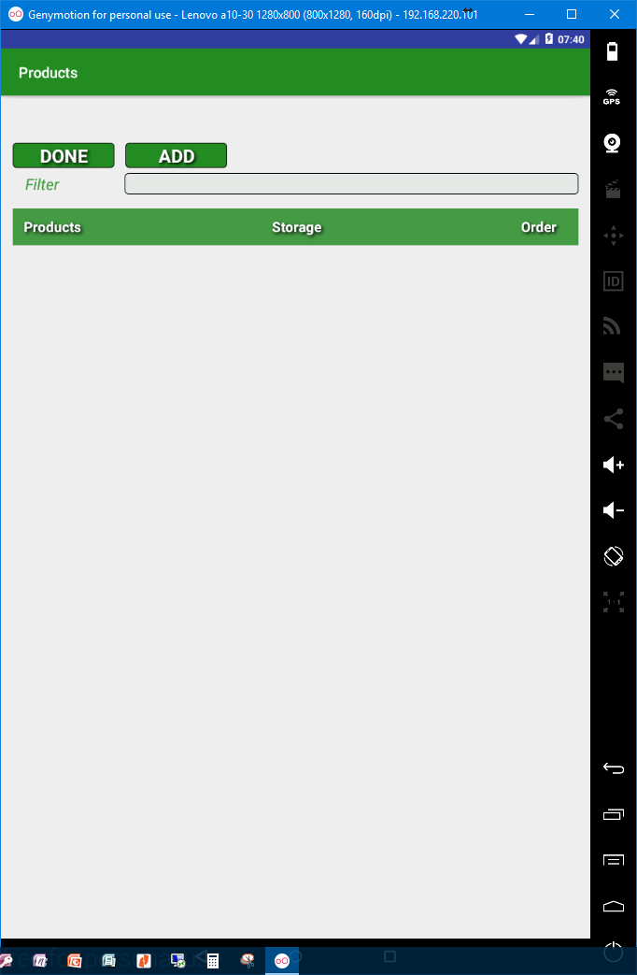

**Products** are the items that may be purchased but at this stage they are not assigned to an **Aisle** (and thus to a **Shop**), rather a **Product** is a more independent or generic representation. Whilst **Stock** is the term used for a **Product** assigned to an **Aisle** and thus **Shop**. A single **Product** can be the basis for multiple **Stock** items.

The existing **Products** are listed, if any. As **Products** will likely be the most prolific item the **Products** **display** includes a filter that allows progressive reduction of the Products listed.

Clicking a list heading (**Products**, **Storage** or **Order**) will sort the list according to the heading clicked. Clicking a heading, when already sorted according to the heading toggles the sort direction between ascending and descending.

Click **DONE** to return to the **Main display**.

Click **ADD** to add one or more **Storage locations**.

# Adding Products

## The Storage – Add Display (click the ADD button from the Storage Display).

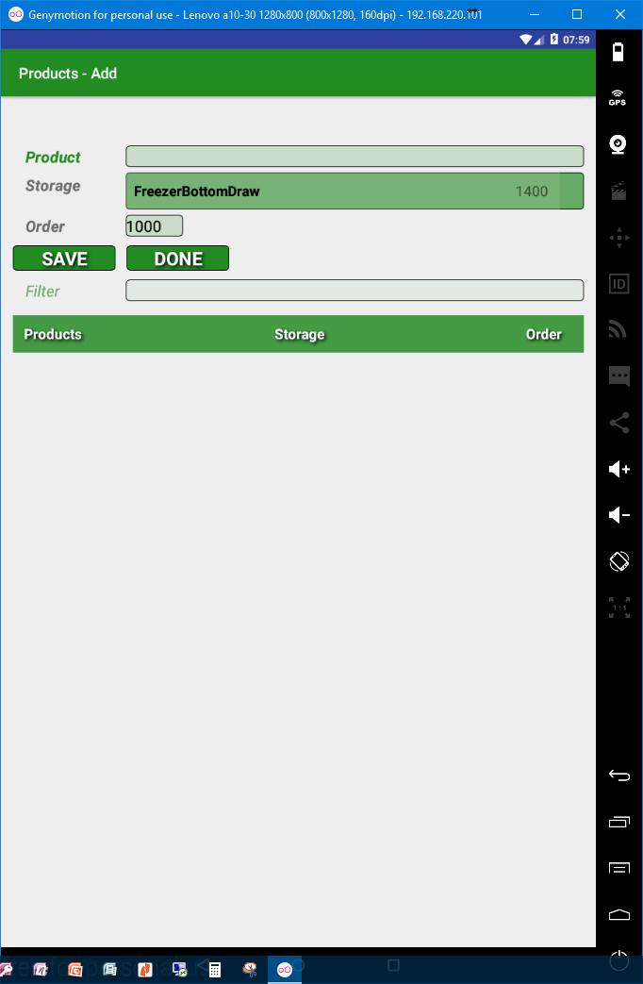

A **Product** has 3 fields; **Product** for the name, **Storage** for the location where the **Product** is stored and **Order** for the order in which the **Product** will appear in the **Checklist**. Lower **Orders** appearing first. All fields are required. **Storage** must be selected from the **DropDown selector**. **Order** is suggested and will be **1000** if no other **Products** exist in the **Storage** location or normally **100** greater than the highest **Order** used for the **Storage** location.

**Products** are listed, if any. **Filter** allows the listed **Products** to be reduced (as there is potential for many **Products**) by typing into the Filter. What is typed is looked for anywhere in **Product** names. The filter is insensitive to case so A is effectively the same as a and vice-versa.

Additionally the **Product** name field also acts as a filter for the list. Thus as you enter a **Product** name to be added, the list will progressively reduce allowing duplicated **Products** to be spotted.

Each filter will override the other. That is, if you typed X in the **Product** name field the list would only display **Products** that have an X (or x) in the **Product** name. If you then typed Q in the filter then the list would only display **Products** that had a Q (or q) in the **Product** name.

## Adding Products

To add a **Product** enter the respective data (**Product name**), select the respective **Storage** location from the **DropDown selector** and change the **Order** if desired.

e.g.

 Type Bread in the product Name

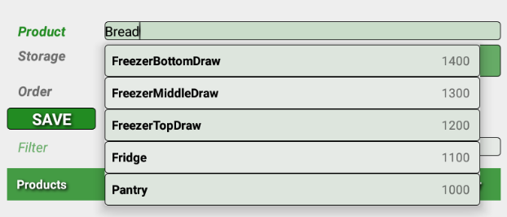 Select Pantry from the DropDown.

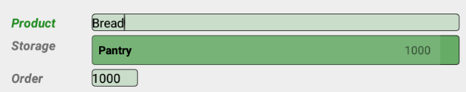 Leave Order as 1000.

Then click on the **SAVE** button. You can repeat this to add more **Products**.

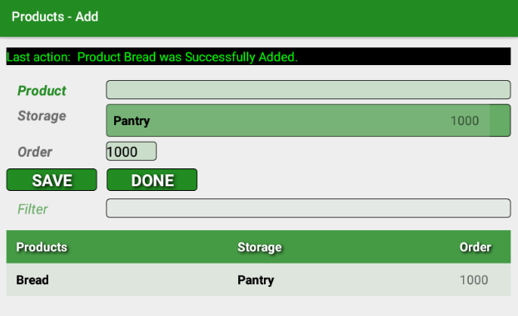

A message is displayed confirming the addition or alternately indicating an issue. If an issue, such as the **Product** field being blank, the message will be yellow instead of green for a successful addition.

The list will be updated with the new **Product**.

Sort the list by clicking on a heading (**Products, Storage** or **Order**). Clicking on a heading when the list is sorted according to the heading clicked will toggle the sort direction between ascending and descending order.

**SAVE** must be clicked to save data.

Click **DONE** to return to the **Products display**.

# Editing Products

Editing **Products** is accomplished from the **Products display** which lists the current **Products**. The **Products display** is reached by clicking the **PRODUCTS** button from the **Main display**. The **Main display** can be reached by clicking on **DONE** until the **Main display** appears.

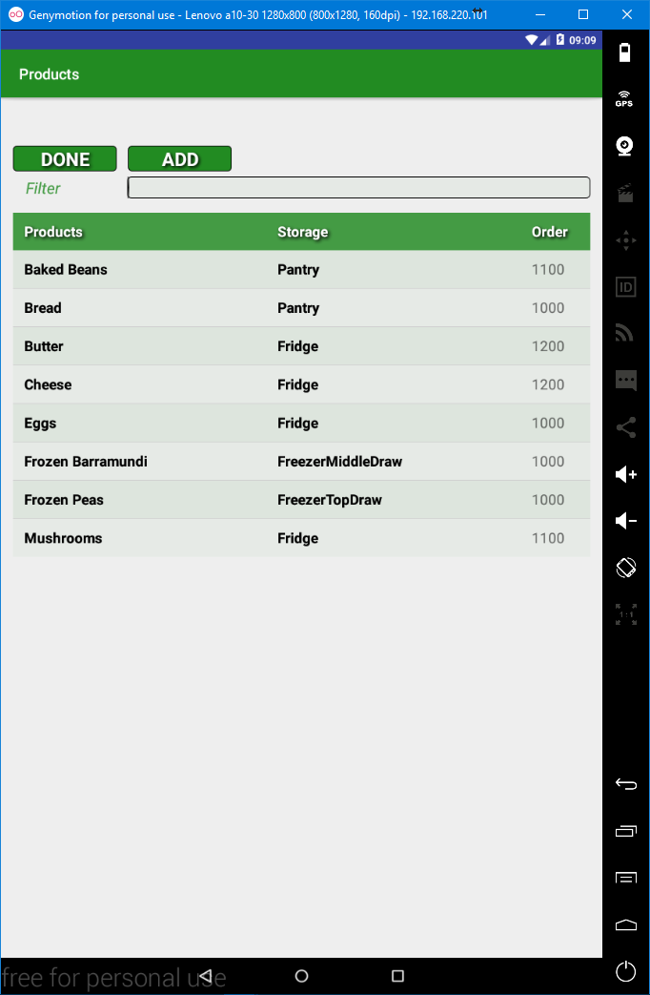

## To edit a Product click on the respective Product in the list. This will result in a dialog appearing. You can select either CANCEL or EDIT or STOCK (if at least one Aisle and one Product exist) from the dialog.

## The Edit Products Dialog

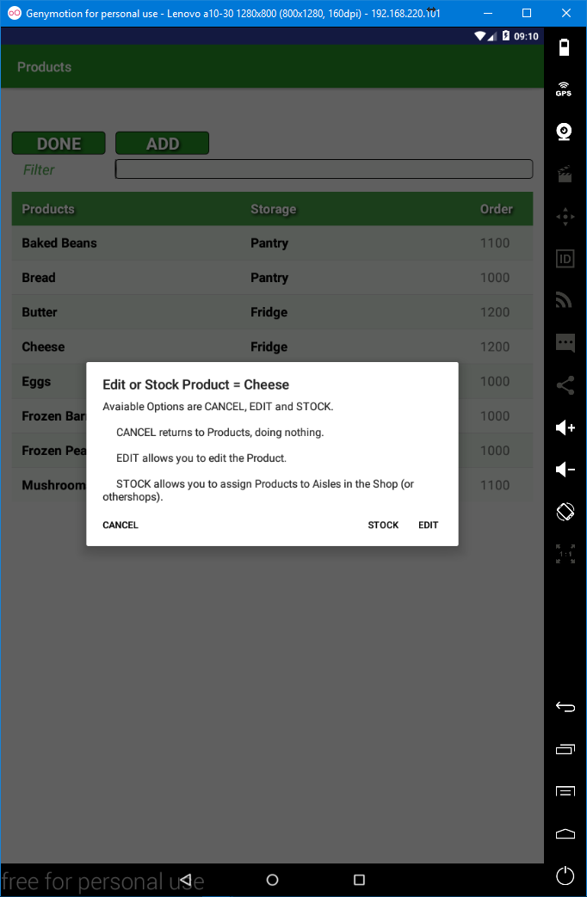

**CANCEL** will return to the **Storage display**, doing nothing.

**EDIT** takes you to the **Storage – Edit display**.

**STOCK** is covered subsequently.

Clicking outside of the dialog (they grey area) is the same as clicking **CANCEL**.

## The Products – Edit Display.

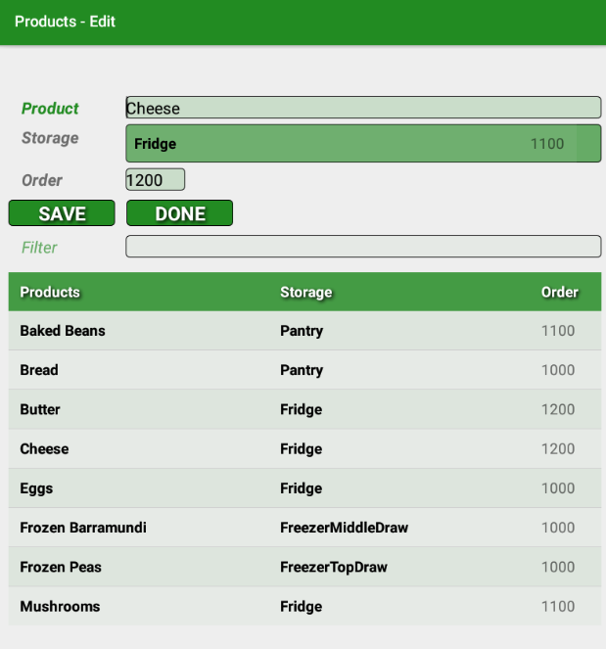

The **Products – Edit display** is the same as the **Products – Add display** except that the title is different and that the fields contain the data from the respective **Storage**.

The **Product name**, **Storage location name** and the **Order** can be changed.

Changes will only be applied if the **SAVE** button is clicked.

Clicking on a heading will sort the list of **Storage** according to the heading clicked. If the list is already sorted according to the heading clicked the sort direction will toggle between ascending and descending.

**Products** are listed, if any. **Filter** allows the listed **Products** to be reduced (as there is potential for many **Products**) by typing into the Filter. What is typed is looked for anywhere in **Product** names. The filter is insensitive to case so A is effectively the same as a, and vice-versa.

Additionally the **Product** name field also acts as a filter for the list. Thus as you enter a **Product** name to be added, the list will progressively reduce allowing duplicated **Products** to be spotted.

Each filter will override the other. That is, if you typed X in the **Product** name field the list would only display **Products** that have an X (or x) in the **Product** name. If you then typed Q in the filter then the list would only display **Products** that had a Q (or q) in the **Product** name.

Clicking or Long-clicking on a **Storage** location in the list does nothing.

Clicking **DONE** will return to the **Storage display**.

# Deleting Products

Deleting **Products** is accomplished by clicking on a **Product** from the list in the **Products Display**. The **Products Display** can be reached by clicking on the **PRODUCTS** button from the **Main display**. The **Main display** can be reached by clicking **DONE** until the **Main display** appears.



To **Delete** a **Product** you long-click on the respective **Product** in the list of **Products**. This will result in a dialog appearing. This dialog allows you to select either **CANCEL** or **DELETE**.

## The Product Delete Dialog

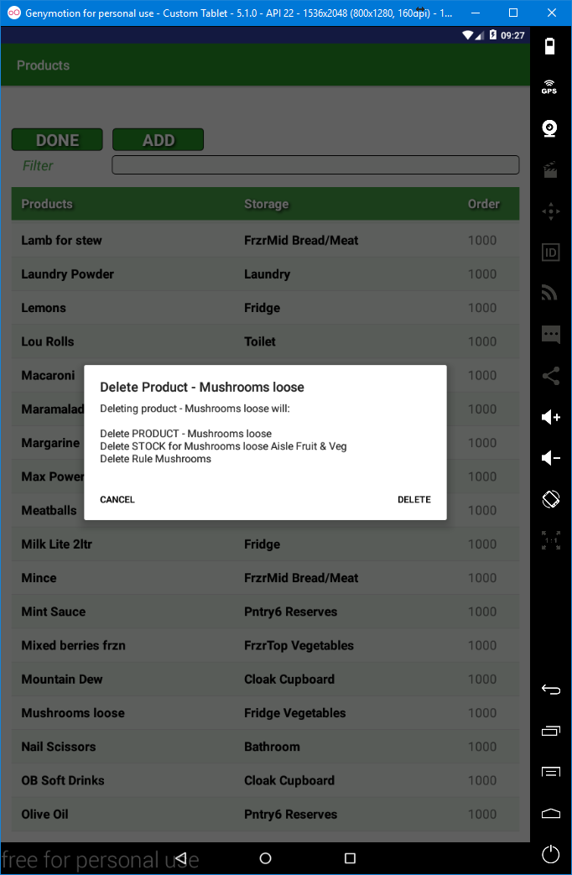

The dialog provides the **impact** that **deleting** the **Product** will have.

**Deleting** a **Product** will **delete all Stock** used by the **Product**. Deletion of any **Stock** will require deletion of any **Shopping List entries** and any **Rules** that use the **Stocked Items**.

Clicking **DELETE** will delete the **Product**.

Clicking **CANCEL** will return to the **Products display** doing nothing.

# STOCK

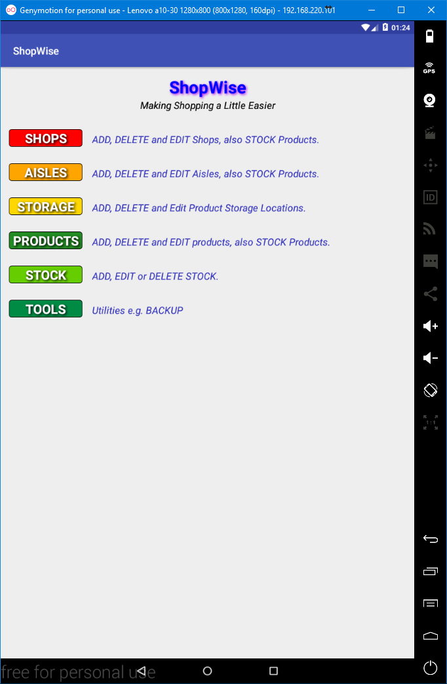

**Stock** is a **Product** that has been assigned to an **Aisle** and thus implicitly a **Shop**. **Stock** has additional values such as its cost. **Stock** also has underlying values, such as how many purchases have been made and when those purchases were made, such values are automatically generated and maintained by **ShopWise**.

There are a number of ways in which **Stock** can be added. **Stock** can be added via **SHOPS**, **AISLES**, **PRODUCTS** and **STOCK**. Adding **Stock** via **SHOPS**, **AISLES** or **PRODUCTS** sets the respective values. E.g. if **Stock** is added via **Aisles** then the **Aisle** and the **Shop** are provided, otherwise all methods ultimately use the same display although the titles and the colour coding will reflect the ancestor.

There is a subtle difference between using **STOCK** and the other three ways of adding **Stock**. From the **STOCK** option the **ADD** button is clicked, whilst from **SHOPS**, **AISLES** and **PRODUCTS** the respective item from the list is clicked and then **STOCK** is clicked from the dialog.

## The Stock Display

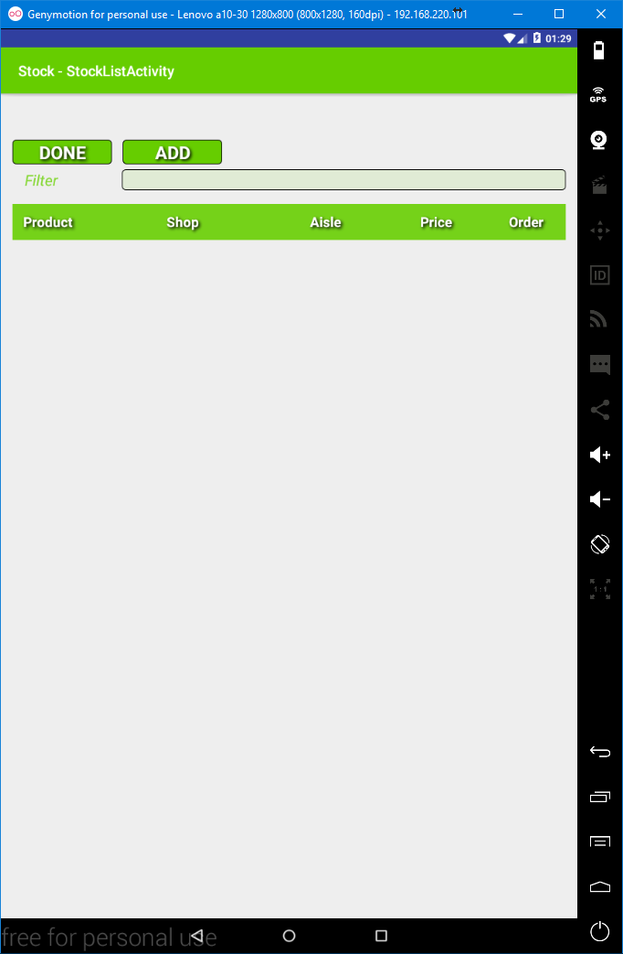

The **Stock display** lists current **Stock**, if any. Values, **Product**, **Shop**, **Aisle**, **Price** and **Order** are displayed. Note that **Order** is the order applied to the **Stock** that is used by the **Shopping List** as opposed to the order applied to the **Product** that is used by the **CheckList**.

The list can be filtered to progressively reduce the list according to the **Product**. As you type into the filter the list will be updated to only display **Stock** that contains what is typed in the **Product** field.

The list can be sorted by clicking on a heading (**Product**, **Shop**, **Aisle**, **Price** or **Order**).

Click **DONE** to return to the Main display.

Click **ADD** to add **Stock**.

# Adding Stock via the Stock Display

## The Stock Add Display (Click ADD from the Stock Display)

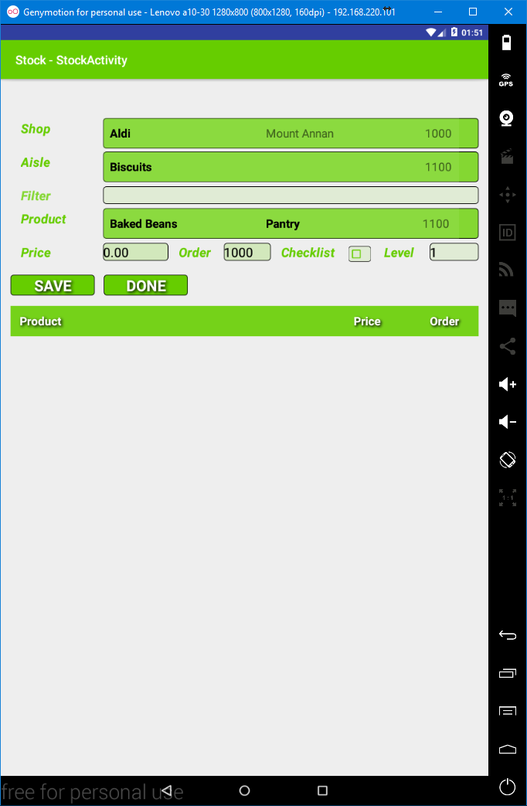

A **Stock** item, from the perspective of adding has 7 input fields, **Shop**, **Aisle**, **Product**, **Price**, **Order**, **Checklist** and **Level**. Additionally there is a filter input field; this filters the list of **Products** displayed by the **Product DropDown selector**.

**Shop** is a reference to an existing **Shop** it can only be a value selected from the **Shop DropDown selector**. Changing the **Shop** will result in the list of available **Aisles** changing. The suggested **Order** may also change. To select a **Shop** click on **the Shop DropDown selector** and then click on the required **Shop**, the **Shop** will then be displayed and it will be the **selected Shop**.

**Aisle** is a reference to an existing **Aisle** within the selected **Shop** and can only be a values selected from the **Aisle DropDown selector**. Changing the **Aisle** may change the suggested **Order**. To select an **Aisle** click on the **Aisle DropDown selector** and the click on the required **Aisle**, the **Aisle** will then be displayed and it will be the selected **Aisle**.

**Product** is a reference to an existing **Product** it can only be a value selected from the **Product DropDown selector**. As the number of **Products** can be quite large the **Product DropDown selector** can be filtered to reduce the **Products** listed by the **Products DropDown selector**. To use the filter type part of the **Product** into the filter (*note you do not see the results until you click on the Product DropDown selector*).

**Price** is how much the **Stock** will cost in the **Shop**/**Aisle**. Note that **Price** is specific to this **Shop**/**Aisle**/**Product** combination. **Price** must be a decimal value. Input is restricted to 9 characters, characters may be 0-9 or a period (.). Only 1 period is allowed. An attempt to save an invalid value will result in a yellow message indicating the issue being displayed with the field being selected for input.

**Order** is the order of the **Stock** within the **Aisle** within the **Shop** and affects the ordering of the **Shopping List**. It is distinct from the **Product’s** **Order** which is used for ordering the **Checklist**. Order will be suggested. The suggestion being **1000** if the **Aisle** has no current Stock. Otherwise, the suggestion will normally be **100** greater than the highest order of current **Stock** within the **Aisle**.

**Checklist**, if ticked, indicates that this **Stock** item will appear in the **CheckList**. The field is clicked to change/toggle the tick.

**Level** is used to represent the number of this **Product** that should be maintained. That is, it is displayed in the **CheckList**. E.g. if you like to have at least 2 Tins of baked beans at home then **Level** would be 2. **Level** defaults to 1.

Click on SAVE to add the Stock. A message will indicate the result. If the message is green then the Stock will have been added. If the message is yellow then the Stock will not have been added and the messages will provide the cause of the issue. If the **Stock** was added it will appear in the list. The price will be reset to 0.00. The suggested **Order** will be incremented, normally by **100**. The checklist will be un-ticked and the level will be reset to 1.

Click on **DONE** to return to the **Stock display**.

# Adding Stock via the Shops, Aisles or Products Displays

Adding Stock from these displays is very much the same as adding Stock from the **Stock Display**, other than;

* The access to the **Stock** add display is initiated from the respective display (**Shops display**, **Aisles display** or **Products display**) the required item (**Shop**, **Aisles** or **Product** respectively) is clicked. This brings up the **STOCK**/**EDIT** dialog and **STOCK** is clicked.
* The respective selectors have the selection reflecting the respective item;
  + If from the Shop display then the selected Shop will be the Shop that was clicked.
  + If from the Aisles display then the selected Shop and Aisle will be as per the Aisle that was clicked.
  + If from the Products display then the selected Product will be the Product that was clicked.
* The colour coding will be as per the parent display i.e. the colour coding will be propagated.
* When DONE is clicked the return will be to the respective display.

# Editing Stock

Existing **Stock** can be edited from the **Stock display** by clicking on a **Stock** item in the list and selecting **EDIT** from the dialog. **Stock** can also be edited by clicking the **Stock** that is listed in the **Stock Add display** and selecting **EDIT** from the dialog. The **Stock Add display** can be reached by clicking **STOCK** from the **Main display** followed by clicking **ADD**. It can also be reached by clicking a **Shop**, an **Aisle** or a **Product** from the **Shops display**, the **Aisles display** or the **Products display**, respectively.

In all cases the same **Stock Edit display** is used. However, the colour coding will be according to the parent display.

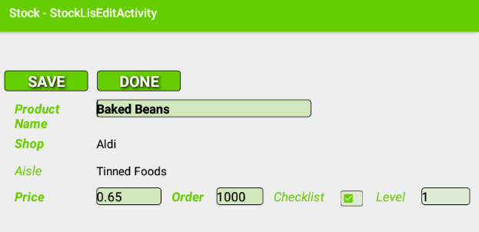

The Stock Edit display allows the following changes to be made:

* The Product’s Name can be changed.
  + Usual naming restrictions apply;
    - A maximum of 24 characters.
    - The Name cannot be blank.
  + NOTE this will affect other **Stock** that uses the **Product**. That is, the change is applied to the **Product** that is referenced.
* The **Price**, **Order**, **Checklist** and **Level** can be changed; these are all specific to the Stock.

The **Edit display** is basically a cut down version of the **Stock Add display**, with the **Shop** and **Aisle** selectors replaced by fixed text and the changeable fields completed as per the existing Stock item.

The **SAVE** button will save any changes made.

The **DONE** button will return to the parent display, doing nothing.

# Deleting Stock

Existing **Stock** can be deleted from the **Stock display** by clicking on a **Stock** item in the list and selecting **DELETE** from the dialog. **Stock** can also be deleted by clicking the **Stock** that is listed in the **Stock Add display** and selecting **DELETE** from the dialog. The **Stock Add display** can be reached by clicking **STOCK** from the **Main display** followed by clicking **ADD**. It can also be reached by clicking a **Shop**, an **Aisle** or a **Product** from the **Shops display**, the **Aisles display** or the **Products display**, respectively.

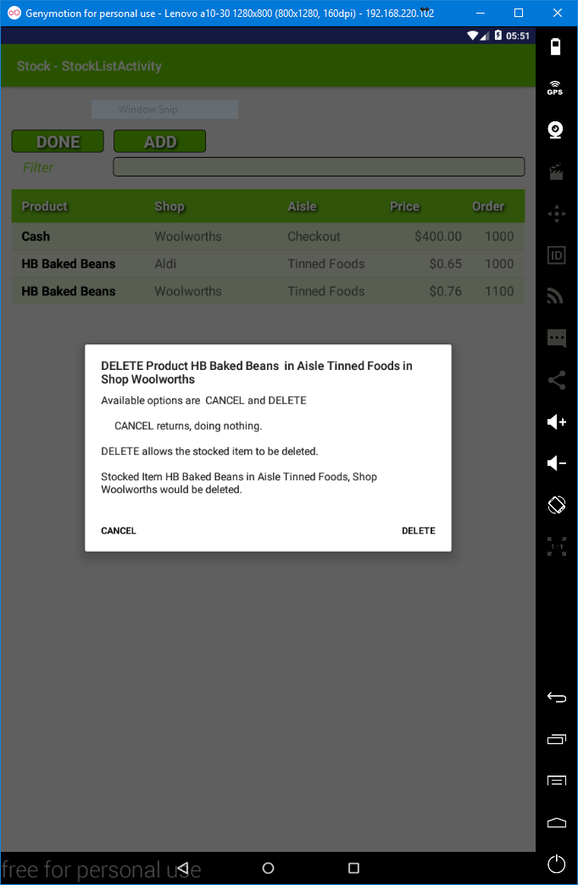

The dialog displayed will show the impact of the deletion as Rules and Shopping List entries may have to be deleted.

Following deletion the display from which the deletion was initiated will be updated.

# ORDER – Adding Adhoc Shopping List Entries

**ORDER**, as is available from the **Main display**, is used to add **Shopping List entries** based upon specific **Products** as an alternative or compliment to using **CHECKLIST** which is used to add **Shopping List entries** based upon checking Storage locations.

Clicking on **ORDER** from the **Main display** results in the **Order display.**

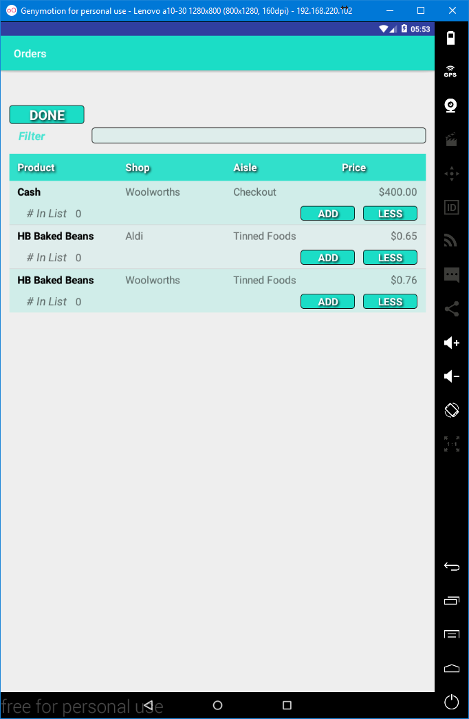

The **Order** display lists all **Stock** or a filtered subset of all **Stock** if the **Filter** is used. The **Filter** is used by typing into the **Filter** input field. After each character is entered the listed Stock is only that Stock that contains the text entered within the Product. E.g. using the list above **c** would only show **Cash**, whilst **a** would show all, and **ak** would only show the two **HB Baked Beans**.

Clicking an **ADD** button in the list will add 1 of the respective item to the **Shopping List**.

Clicking a **LESS** button in the List will remove 1, of the respective item from the **Shopping List**, if it as least 1 is in the **Shopping List**. That is, the number will not go below 0.

The **# in List** indicates the number of that respective item in the **Shopping List**.

The list can be sorted by clicking on a heading. The list will be sorted according to that heading. If a heading is clicked and the list is already sorted by that heading then the sort will toggle between ascending and descending order. A message is displayed indicating the sort order.

Clicking **DONE** will return to the **Main display**.

# CHECKLIST - Adding Shopping List entries based upon what you have.

**CHECKLIST**, as is available from the **Main display**, is used for adding **Shopping List entries** based upon the **Level** of **Stock** held in **Storage locations**. **Stock** must be set to appear in the **CheckList**, the **checklist** field needs to be ticked when adding or editing **Stock**.

Clicking on **CHECKLIST** from the Main display shows the **Checklist display**:

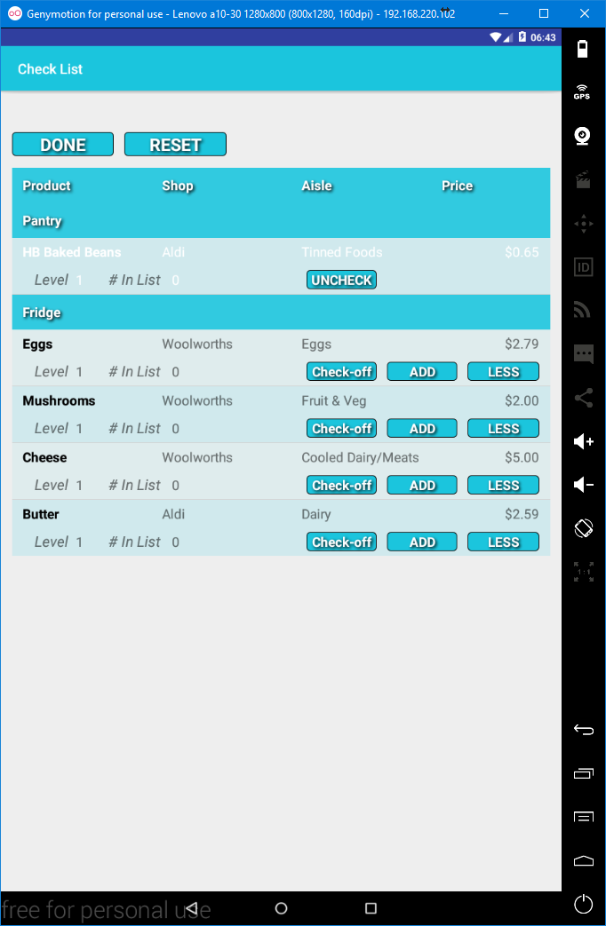

This is a list of **Stock** that is to be checked against what is stored at the respective **Storage locations**. The list has a main heading with **Product**, **Shop**, **Aisle** and **Price**. For each **Storage location** a secondary heading exists with the name of the **Storage location**. The secondary heading is followed by the **Stock** assigned to the **Storage location,** if it has been set to appear in the **CheckList**.

The list cannot be sorted by clicking on a heading, the sort order is fixed.

Based upon the above, the **Pantry** has been checked. The **Pantry** had the 1 tin of **HB baked beans** (**Level** 1) so **HB Baked Beans** were not added to the **Shopping List** **(# in List** 0). The **Check-off** button was clicked so **HB Baked Beans** has been crossed off (text was changed to white, the **Check-off**, **ADD** and **LESS** buttons have been replaced by a single **UNCHECK** button).

The **DONE** button will return to the Main display. Note that the status is maintained, checked-off items will remain checked-off.

The **RESET** button changes all entries to an unchecked status (it does not change the # In List). You would typically click on the RESET button before starting a check.

The **Check-off** button is used to mark an item as checked-off. In which case the **Check-off**, **ADD** and **LESS** buttons are replaced by the **UNCHECK** button.

The **ADD** button will add 1 of the respective item to the **Shopping List**. The **# in List**, which displays how many of the item are currently in the Shopping List, will be increased by 1.

The **LESS** button will deduct 1 of the respective item from the **Shopping List** if there is at least 1 in the **Shopping List**. The **# in the List**, will be changed to reflect the changed number in the **Shopping List**.

The **UNCHECK** button will change the status of the respective item from checked-off to unchecked.

# SHOPPING

## The Shopping List (Main Display SHOPPING)

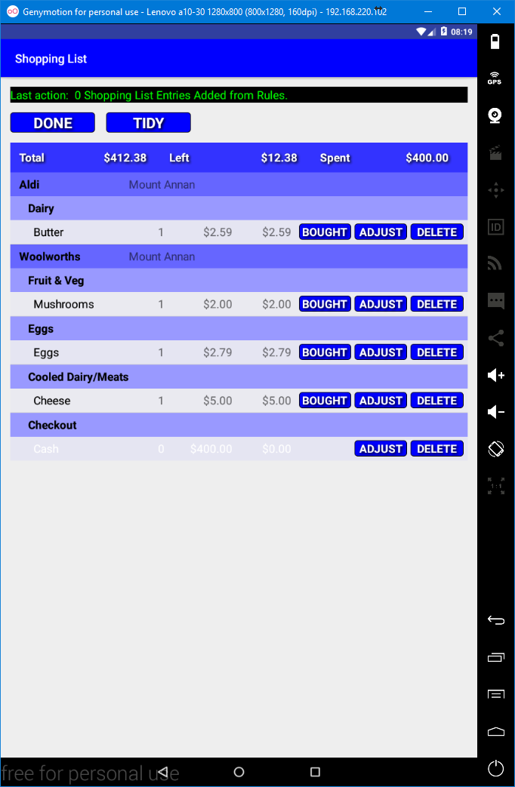

The **Shopping List** is displayed by clicking on **SHOPPING** from the **Main display**. It lists the **Stock** that has been added via **ORDER**, **CHECKLIST** or **RULES**.

It may at times be empty; this indicates that no **Shopping List entries** have been added.

The **DONE** button will return to the **Main Display** it’s status is maintained although it will reflect changes made by **ORDER**, **CHECKLIST** or **RULES** when re-displayed.

The **TIDY** button removes checked-off entries and alters the underlying data to negate purchased **Stock**. The underlying data consists of two data items, the number ordered and the number purchased, the quantity is the number remaining to be purchased i.e. the underlying number ordered less the number purchased. In short using **TIDY** will carry over un-purchased entries for the next Shopping. **TIDY** will generally be used when the **Shopping** has been completed, in preparation for the next use of **SHOPPING**.

The **Heading** displays the **Total** Cost of the Shopping, the amount **Left** (i.e. the total of the current items yet to be purchased) and the amount **Spent**. (*e.g. in the above the Cash costing 400 has been purchased*). Adjusting the Price of an entry would result in the amounts changing accordingly.

The order of the list is fixed; clicking headings will not alter the sort order. The order will always be **Shop** order (lowest to highest), **Aisle** order (lowest to highest) within the **Shop** and then **Stock** order (lowest to highest) within the **Aisle** (and thus **Shop**).

Each **Shop** has a heading (secondary) with the **Shop** and it’s **City**.

Each **Aisle** has a heading (tertiary) with the **Aisle**.

Each **Stock** item has a row with either 3 (when not checked-off) or 2 ( when checked-off) buttons.

The **BOUGHT** button is used to reflect purchase of the item (generally clicked when 1 of that item is placed into the Trolley, cart, basket). Clicking the **BOUGHT** button will reduce the quantity to purchase (the *number that immediately follows the* ***Product***) by 1 but to no lower than 0. When the quantity to purchase reaches 0, then the entry is automatically checked-off, the text colour is changed to white and the **BOUGHT** button is removed.

The **DELETE** button removes the entry from the **Shopping List**, without making any underlying adjustments. That is, the **Stock’s** last purchase date is not changed nor is the purchase count for that **Stock** changed. It is likely that you would not use the **DELETE** button to reflect being unable to purchase the item, rather you would likely just skip the item, as leaving it will leave the item on the **Shopping List** for the next **Shopping**. However, if you preferred to have a cleared **Shopping List** then you could **DELETE** the entry.

The **ADJUST** button will display the **Adjust display**.

## The Adjust Display (click ADJUST button on Shopping List)

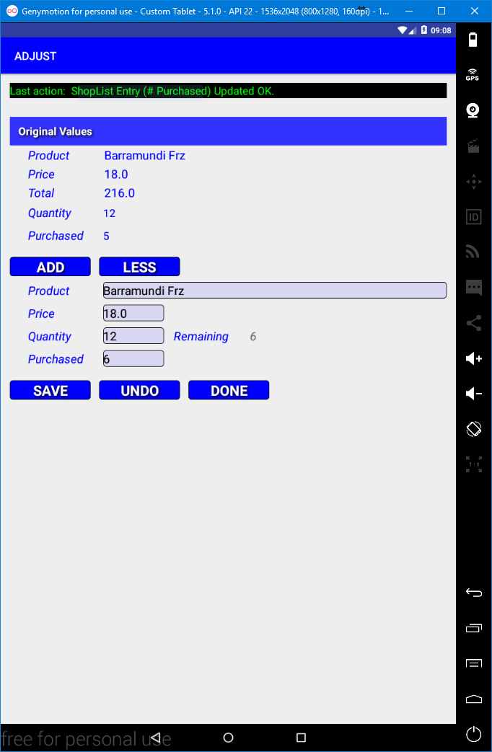

The **Adjust display** allows the respective **Shopping List entry** to be edited. That is, the **Shopping List entry** that was clicked. In the case of the **Product Name** the underlying **Product** itself is changed if it is edited. The original values are also displayed.

Clicking the **ADD** button will increase the **Quantity** by 1. Clicking the **LESS** button will reduce the **Quantity** by 1 but only if the **Quantity** is 1 or more (*i.e. the* ***Quantity*** *cannot be changed to be less than 0*).

Entering a new value in the **Product** field allows the **Product name** to be changed. The change will be applied to the Product itself and will thus be reflected in all **Stock** that uses the **Product**.

Entering a new value in **Price** allows the **Price** to be changed. **Price** must be a valid decimal number.

In addition to the **ADD** and **LESS** buttons the **Quantity** can be changed by entering a new **Quantity**. The value entered must be between 0 and 9999, only numerics can be entered. **Quantity** is restricted according to **Purchased** (the number bought) you cannot reduce Quantity to be below the number Purchased, a message will be displayed if **SAVE** is clicked.

**Purchased** allows you to adjust how many have been bought. Noting that adjustments are not made to the recorded purchases. If **Purchased** is greater than the **Quantity** then clicking **SAVE** will issue a message:-



Changes will only be applied by clicking the **SAVE** button.

The **UNDO** button will change all values back to the values that they originally were before the **ADJUST** button was clicked, thus allowing the original values to be saved by clicking on the **SAVE** button.

The **DONE** button returns to the **Shopping display**, doing nothing and not saving any changes that haven’t been saved.

# RULES

Rules allow Shopping List entries to be added automatically or semi-automatically (a prompted rule). Rules are suitable for items that are purchased on a regular basis rather than on a replenishment basis. Rules would be suitable for perishable items such as milk.

## The Rules display (click RULES from the Main display)

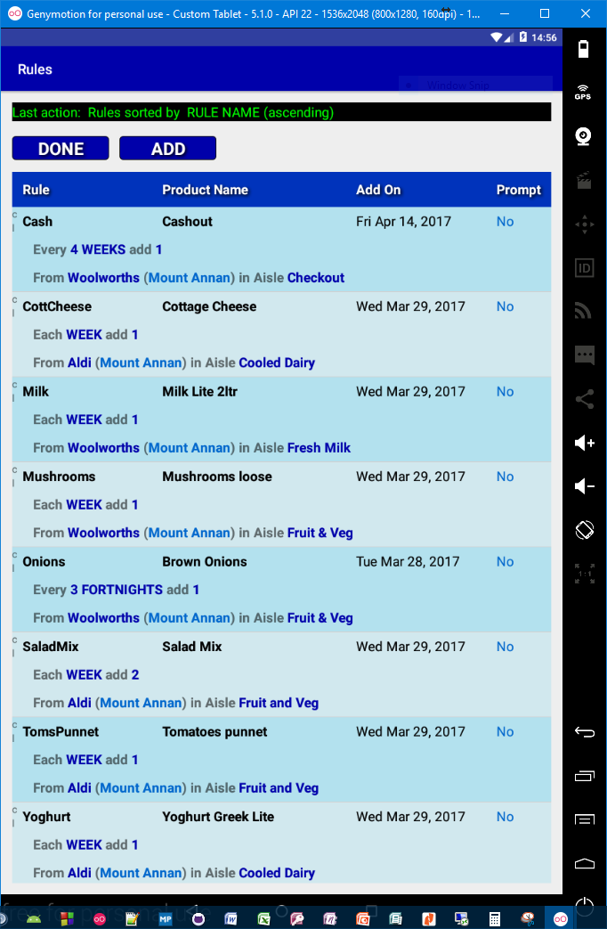

Note until **Rules** are added the list would be empty (the heading with **Rule**, **Product Name**, **Add On** and **Prompt** would be shown but nothing would appear below the heading). The list in the above shows 8 **Rules** for illustration.

The **DONE** button will return to the **Main display**, doing nothing.

The **ADD** button will display the **Rule Add display** (this will be covered shortly).

### The List

Each entry in the list consists of 3 lines. The first line has the **Rule Name,** the **Product Name**, the date that the rule be next applied (**Add On**) and whether or not the **Rule** is a **Prompted Rule**.

* A **Prompted Rule** is one that will prompt for it to be added or skipped when **SHOPPING** is clicked. Prompted Rules will be covered shortly.
* **Add On** is the earliest date that the rule will be applied and that the Shopping List Entry will be added.
  + **Rules** are applied when **SHOPPING** is clicked from the **Main display**.
  + The calculation of a Rule’s next application date happens when the rule is applied, if that date is on or before the current date then the rule will be applied again and result in the quantity being adjusted accordingly *(if, for example, a weekly* ***Rule*** *existed and it was 4 weeks since* ***SHOPPING*** *was clicked then that* ***Rule*** *would be applied 4 times, or in the case of* ***Prompted Rules****, be prompted 4 times, each appearing in the list of Prompted Rules (not this list) only after its predecessor have been dealt with*).

The second line indicates the regularity of the Rule and the quantity that will be added to the Shopping List. (e.g. for Every 4 WEEKS add 1 the regularity is every 4 weeks and the quantity to add is 1). Regularity will be covered in more detail shortly.

The third line specifies the **Shop** and **City** (in brackets) and the **Aisle**.

The list can be sorted by clicking on a heading. If a heading is clicked and the list is already sorted according to that heading then the sort order will toggle between ascending and descending order for the heading.

# Adding Rules

## Adding Rules (click the ADD button from the Rules display)

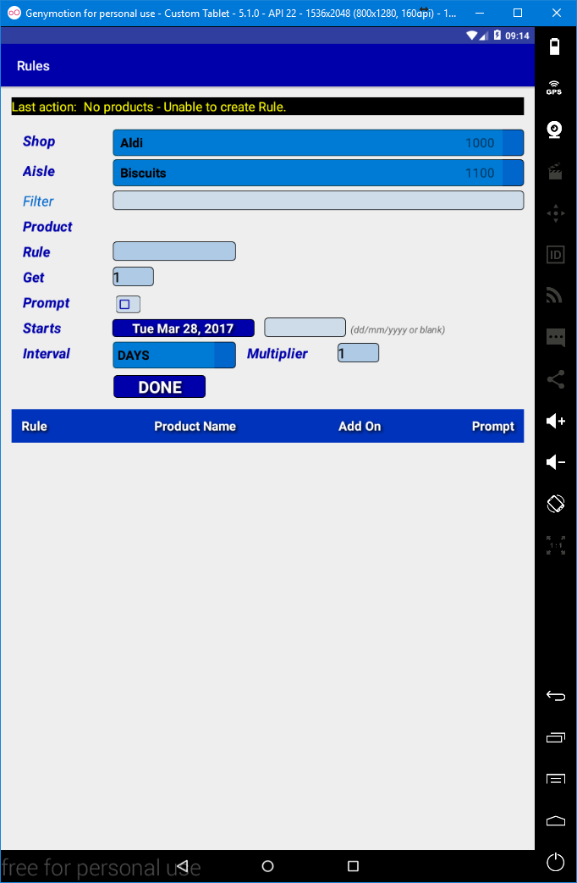

A **Rule** is based upon a **Stock** item, thus the **Shop**, **Aisle** and the **Product** are required to determine the **Stock**. All three are selected from DropDown selectors that are linked. The **Shop DropDown selector** determines the available **Aisles** and the **Aisles DropDown selector** determines the available **Products**. If a **Shop** is selected that has no **Aisles** then the **Aisle DropDown selector** will not appear nor will the **Product DropDown selector** appear. If an **Aisle** is selected that has no **Products** in it then the **Products DropDown selector** will not appear. If there are no **Products** available then a yellow message will appear and the **SAVE** button will not be available.

As such to be able to **ADD** a **Rule** and **SAVE** it the **Shop** selected must have **Aisles** and the Aisle selected must have **Products**.

There is also a filter for field that can be used to restrict which **Products** are listed in the **Products DropDown selector**.

Below all the inputs and the **DONE** and **SAVE** button ( **SAVE** is not always visible) is a list of any **Rules** that exists in the selected **Aisle** (and thus **Shop**). The list of existing **Rules**, if any, is for reference only. No actions are available if a **Rule** is clicked or long-clicked.

The following is an example of the **Rule Add display** where **Stock** exists in the **Shop**/**Aisle** and existing **Rules** exist. However, none of the inputs (e.g. Rule) have been input.

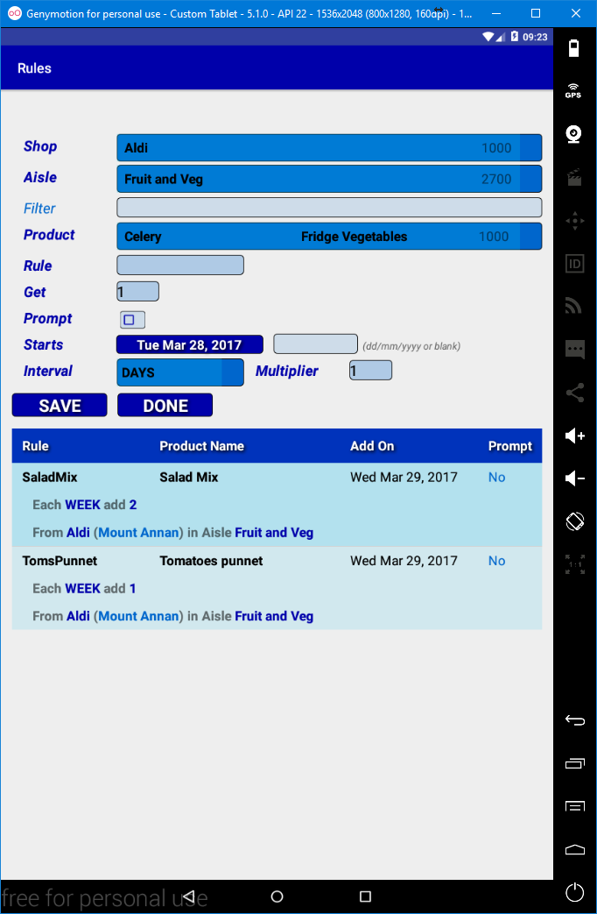

To recap, a **Rule** can only be made for existing **Stock** in the selected **Shop/Aisle**. The **SAVE** button will appear. Only then should the other inputs be provided. The list of existing **Rules** may also contain **Rules**

Rule, is required and is a name for the Rule and can be a maximum of 24 characters in length.

Get is the quantity of the Stock that is to be added to the Shopping List when the Rule is activated.

**Prompt**, if ticked, makes the **Rule** a **Prompted Rule**; the **Rule** will appear in a list of **Prompted Rules** that is displayed when **SHOPPING** is clicked. **Rules** that are not **Prompted** are added, when activated, directly to the **Shopping List**.

**Starts**, is the date that the **Rule** will be activated. This will automatically be changed when the **Rule** has been activated. It will change according to the **Interval** and **Multiplier** values. **Starts** can either be selected by clicking on the button with the **Date** (it will be the current date by default) or the date can be entered into the following field in **dd/mm/yyyy** format e.g. 28/03/2017 (28th March 2017). If the button with the date is clicked then the Android in-built **Date-Picker** will be displayed. Note the Date-Picker is dependent upon the Android version.

**Interval** and **Multiplier** together determines the regularity of the **Rule**. **Interval** is a **DropDown** selector from which specific values can be selected. These, **DAYS**, **WEEKS**, **FORTNIGHTS**, **MONTHS**, **QUARTERS** and **YEARS** should be self-explanatory. The **Multiplier** is a number by which the Interval is multiplied to determine the interval between activations. E.g. **WEEKS** (interval) **10**(multiplier) means that the **Rule** would be activated every **10 Weeks** starting on the **Starts** date.

The **SAVE** button must be clicked to **SAVE** a Rule. Any errors will be displayed as a yellow message and the **Rule** will not be saved. If **0** is given as a multiplier it will be converted to **1** and the **Rule** will be saved. A saved Rule will appear in the list of existing **Rules**.

Multiple **Rules** can be made for the same **Stock** thus catering for complex situations.

# Editing Rules (click on a Rule listed in the Rules Display)

Existing **Rules** can be edited from the **Rules display** by clicking on a **Rule** item in the list and selecting **EDIT** from the dialog. The **Rule Edit display** is then displayed. This is similar to the **Rule Add display** but with all fields populated by the values obtained from the **Rule** being edited and that the **Shop**, **Aisle** and **Product** **DropDown** selectors are locked so that the **Shop**, **Aisle** or **Product** cannot be changed.

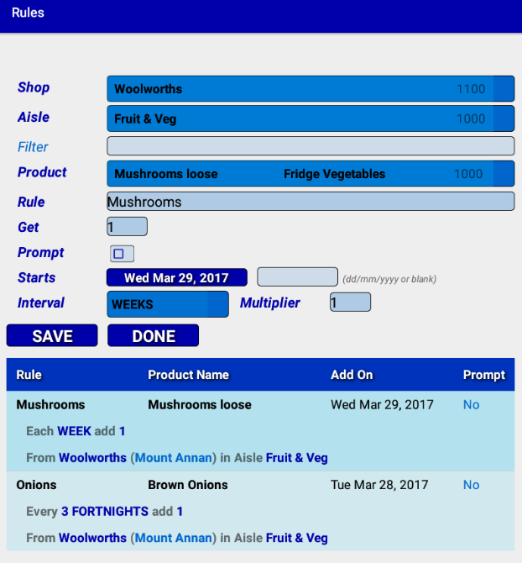

The Rule Edit display allows the following changes to be made:

* The Rule’s Name can be changed.
  + Usual naming restrictions apply;
    - A maximum of 24 characters.
    - The Name cannot be blank.
* The **Get** (quantity to get), **Prompt**, **Starts**, **Interval** and **Multiplier** can be changed.

The **SAVE** button will save any changes made.

The **DONE** button will return to the parent display, doing nothing.

The List displays **Rules** that exist for **Stock** in the same **Shop/Aisle**.

# Deleting Rules (long-click a Rule listed on the Rules Display)

A **Rule** can be deleted by clicking on the respective rule from the **Rules Display**, which can be accessed by clicking **RULES** from **the Main Display**.

A dialog will appear showing the impact of the deletion that allows either **CANCEL** or **DELETE** to be clicked. The impact of deleting a Rule is just the deletion of that Rule. Any **Shopping List** entries entered due to the activation of the **Rule** will not be deleted.

Clicking **CANCEL** will return to the **Rules Display**, doing nothing.

Clicking **DELETE** will return to the **Rules Display** after deleting the respective **Rule**.

# Prompted Rules

Prompted Rules are activated, as are normal unprompted Rules, by clicking on Shopping from the Main display. If there any Prompted Rules then first a dialog will appear as a reminder that there are Prompted Rules.

## The Prompted Rules Dialog

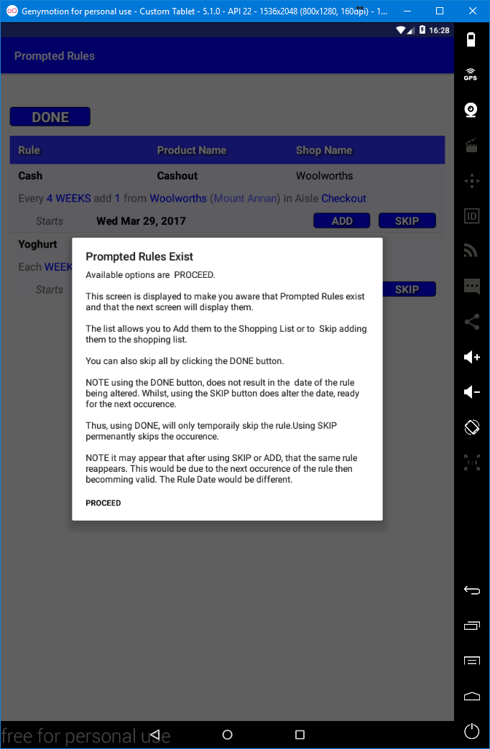

Clicking on **PROCEED** will the display the **Prompted Rules display**.

## The Prompted Rules Display

## 

Clicking **DONE** will not return to the **Main display** instead it will result in the **Shopping List** being displayed without adding any remaining **Prompted** **Rules** and without updating the activation date, as such any remaining **Prompted Rules** will re-appear the next time that **Shopping** is clicked. Note this is unlike using **SKIP**.

Clicking **ADD** will activate the respective **Prompted Rule** and thus add the respective **Shopping List entry**, the **Starts** date will be updated by adding the **Rule’s** interval to the date thus resulting in the **Rule** now having the next activation date. If the new date is on or before the current actual date, then that instance of the **Prompted** **Rule** will appear as a **Prompted Rule** in the list (this will repeat until the **Rule** has caught up).

Clicking **SKIP** is similar to clicking **ADD**, except that no **Shopping List entry** is added. The **Prompted Rule’s** date will be amended and will repeat until the **Prompted Rule** has caught up. As previously stated **SKIP** is not the same as clicking **DONE**, that is **DONE** moves to the **Shopping List** without adding any **Shopping List entries** and without changing **Prompted Rule** dates.

When clicking **ADD** or **SKIP** on the last Prompted Rule (considering catchup), the **Shopping List** is automatically displayed, rather than displaying a blank list. As such the **Prompted Rules List** should never be empty.

The **Prompted Rule list** can be sorted by clicking on the headings **Rule**, **Product Name** and **Shop Name**. The list will be sorted according to the heading clicked. If a heading is clicked and the list is already sorted according to that heading then the sort order will toggle between ascending and descending.

Clicking or long-clicking on a **Prompted Rule** in the list has no affect.

# Rule Suggestion and Rule Accuracy Checking

**Rule Suggestion** is the suggestion of **Rules** which may then be added as an actual **Rule**. **Rule** **Accuracy Checking** is checking the accuracy of existing **Rules**. Both utilise the historical data maintained by **ShopWise**.

This historical data is limited to the first and last purchase date and the number of purchases per Stock Item. More specifically whenever the BOUGHT button is clicked in the Shopping List the purchase count is incremented and the timestamp is applied to the last purchase date and if not present to the first purchase date.

The accuracy or reliability of the data, in regards to calculating values, increases over time. **ShopWise** suggests a minimum period of 30 days with a minimum of 5 purchases, as will be seen.

Both **Rule Suggestion** and **Rule Accuracy Checking** are initiated from the **Tools Rules display**. The display is accessed by clicking **TOOLS** from the **Main display** and then by clicking **RULES** from the **Tools display**.

## The Tools Rules display

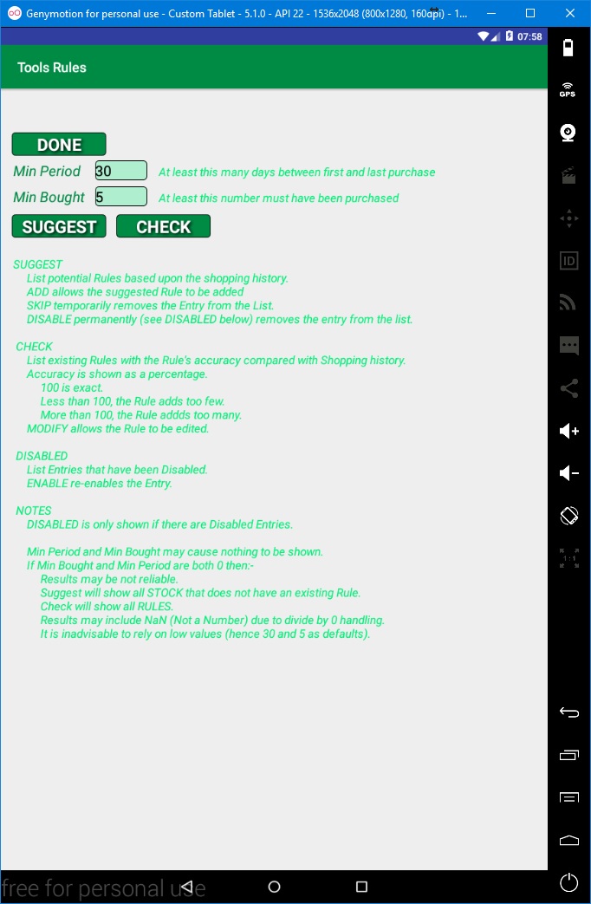

Clicking **DONE** will return to the **Tools display**, doing nothing.

**Min Period** is required and must be an integer in the range of 0-9999. **Min Period**, is used, as a factor in determining what **Stock** is included. That is, it restricts the **Stock** considered to **Stock** whose **Last Purchase Date** is at least **Min Period** days after the **First Purchase Date**. The default value is 30 days, approximately 1 month.

**Min Bought** is required and must be an integer in the range of 0-9999. **Min Bought**, is used, as a factor in determining what **Stock** is included. That is, it restricts the **Stock** included to **Stock** whose **Purchase Count** is **Min Bought** or greater. The default value is 5, that is only Stock that has been purchased 5 times will be included.

For **Stock** to be included neither the **Min Period** or the **Min Bought** restriction should apply.

Clicking the **SUGGEST** button will display the **Rule Suggestion List**.

Clicking the **CHECK** button will display the **Rule Accuracy Check List**.

Clicking the **DISABLED** button, only available when **Stock** has been marked as **Disabled** for **Rule Suggestion** (see **Rule Suggestion List**), will display the **Disabled Rule List**.

## Example of the Tools Rules display with the DISABLED button present.

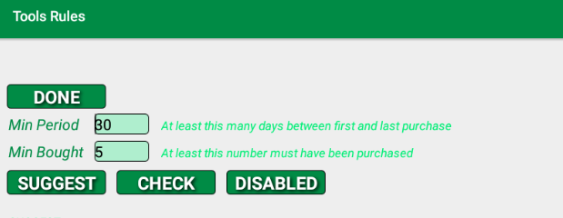

# Rule Suggestion (click Suggest on the Tools Rules Display)

## The Rule Suggestion List

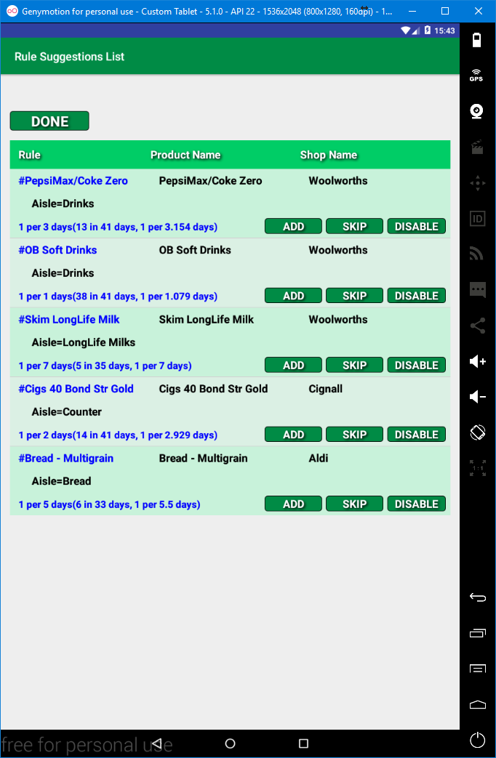

The **Rule Suggestion List** displays potential **Rules** with a suggested name (the Product Name prefixed with #) and a suggested interval in days for adding 1 of the respective **Stock** to the **Shopping List**. **Potential Rules** are restricted according to the **Min Period** and **Min Bought** and additionally only for **Stock** that does not have an existing **Rule**.

Text in blue indicates calculated data that will form part of the Rule that would be added. The Rule’s name is simply the Product Name prefixed with #. The Rule’s frequency is determined from the historical data (first and last purchase date and the number purchased).

Clicking the **SKIP** button will temporarily remove the potential **Rule** from the List (clicking **DONE** and then **SUGGEST** would display the skipped **Rule** again).

Clicking the **DISABLE** button will permanently stop the potential **Rule** from being displayed. That is, unless it is re-enabled via the **DISABLED** button on the **Tools Rules display**.

The List can be sorted by clicking on either the **Product Name** or **Shop Name** heading (the **Rule** heading is disabled as it would be the same as sorting according to **Product Name**).

## Rule Suggestion Frequency and Quantity Determination

If we look at the Rule Suggestion:

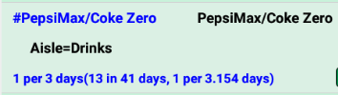

The suggestion would according to “**1 per 3 days”**; place **1** in the **Get** field, select **DAYS** as the **Interval** and use **3** as the **Multiplier** (as per adding a rule). This based upon **13** having been purchased over **41** days which equates to **1** being purchased every **3.154** (41 / 13) days. As you can only purchase units (*few if any, Shops would sell .154 of a can of baked beans so the amount to be purchased must be an integer, so the quantity used is 3.154 rounded = 3*).

In some situations the number purchased may be more than 1 per day and thus the rate to buy 1 would be less than 1 e.g. (0.425) as per:

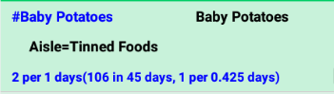

In such a case the calculation based upon a rate of 0.425 and using the above would result in 0 per day, which would be adjusted to 1 per day, which would be insufficient. Therefore if the period to buy 1 is less than 1 then 1 is divided by the rate and then the quantity is multiplied by the result

in the above 1 / 0.425 = 2.35, so 1 * 2.35 = 2.35 which when rounded = 2.

In many cases Rule Suggestion will not be accurate; rather it is an indication or a ball park figure. Rule Suggestion only uses an interval of days. As such it is advisable to check Suggested Rules when adding them.

# Adding a Suggested Rule

Clicking an **ADD** button displays the **Rules Add display** with all input fields completed with the respective values. The **Prompt** field being left un-clicked and the **Starts** field being set to the current date. E.g. Clicking **ADD** for the first potential Rule (#PepsiMax/Coke Zero) would display:

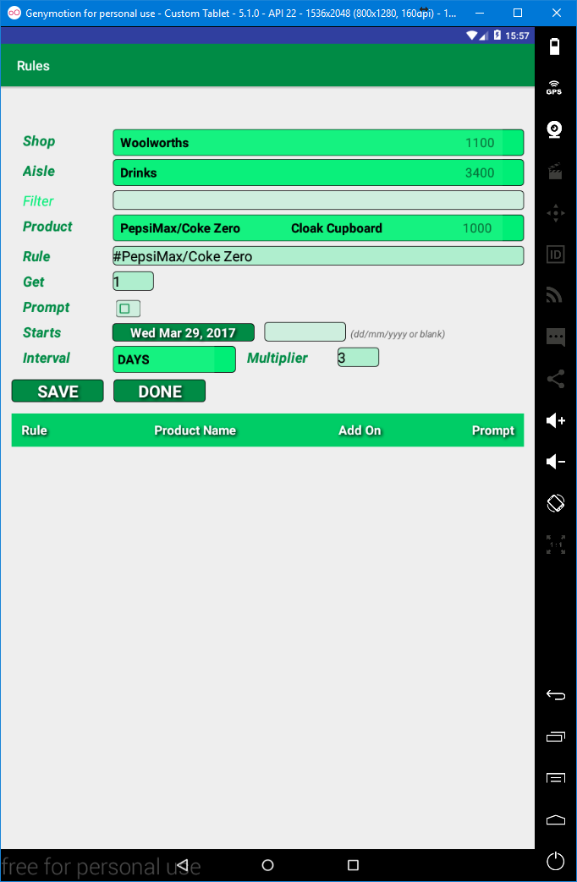

The **Shop**, **Aisle** and **Product** cannot be changed. The **Filter** field is disabled.

**Rule** (the Rule’s name) **Get**, **Prompt**, **Starts**, **Interval** and **Multiplier** can be changed.

The **Rule** is only added when the **SAVE** button is clicked and if no issues are reported (e.g. a blank rule name would be an issue).

Clicking **DONE** will return to the **Rule Suggestion List**, doing nothing.

# Re-instating DISABLED Rule Suggestions (click TOOLS then RULES)

Note **DISABLING** only disables the **Stock** item from appearing in the **Rule Suggestion List**. A **Rule** can still be added for the **Stock** item via **RULES**.

If there any **Disabled Rules** then the **Tools Rules display** (click **TOOLS** from the **Main display** and then click **RULES** from the **Tools display**) will have a **DISABLED** button.

Clicking the **DISABLED** button will display the **Disabled Rules List display**. This lists any **Disabled Rules**. Clicking on the **ENABLE** button, will re-enable **Rule Suggestion** for the respective **Stock** item and remove the entry from the list. If no entries are left then the **Rules Tools display** will appear and the **DISABLED** button will be hidden.

Clicking the **DONE** button returns to the **Rules Tools display**, doing nothing.

The **Disabled Rules list** can be sorted by clicking on the headings **Rule**, **Product Name** and **Shop Name**. The list will be sorted according to the heading clicked. If a heading is clicked and the list is already sorted according to that heading then the sort order will toggle between ascending and descending.

Clicking or long-clicking on a **Disabled Rule** in the list has no affect.

# Rule Accuracy Checking (click CHECK on the Rules Tools Display)

## The Rule Accuracy Check List

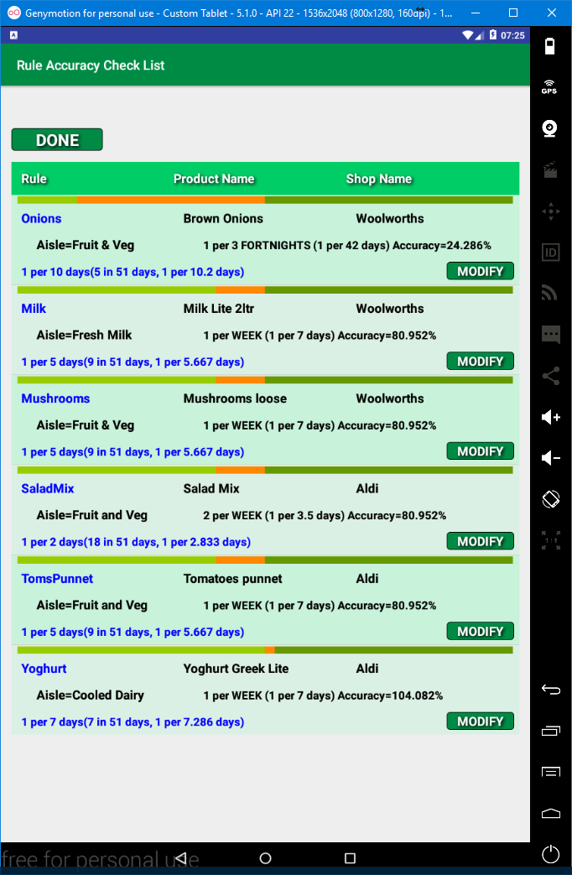

The **Rule Accuracy Check List** displays existing **Rules**, restricted according to the **Min Period** and **Min Bought** values. Each list entry includes two measures of the accuracy of the Rule as percentage.

The percentage being between the Rule as stored and the historical purchase data.

One measure is the bar at the top of an entry, this gives a visual representation, as the accuracy of the rule worsens, more orange is shown. If the orange is to the left of the centre (a percentage below less than 100%) indicates that the Rule adds too few to the Shopping List. If the orange is to the right of the centre (a percentage greater than 100%) then the Rule adds too many to the Shopping List.

The second measure is the percentage as a numeric value to 3 decimal places that follows the frequency according to the Rule (the black text in the middle of the entry, Accuracy=???.???). If the value is below 100 then too few are added to the Shopping List (orange to the left of the centre). If the percentage is greater than 100 (orange to the right of centre) then too many are added to the Shopping List. 100% (no orange) indicates that the Rule is exact.

The frequency in blue on the bottom line is the frequency that is suggested as a modification. Note that this always appears, even if the percentage is 100%. The suggestion may also suggest a match with the current frequency (e.g. Yogurt in the list suggests 1 per 7 Days, the same as the current Rule). Accuracy is only a guide it may well show an inaccuracy but be reasonable. Suggestions will always use Days as an interval.

Clicking the **MODIFY** button displays the **Rule Edit display** and will set the **Get**, **Interval** and **Multiplier** inputs according to the suggestion. The SAVE button has to be clicked to modify the **Rule**.

Clicking DONE will return to the **Tools Rules display**.

The **Rule Accuracy Check list** can be sorted by clicking on the headings **Rule**, **Product Name** and **Shop Name**. The list will be sorted according to the heading clicked. If a heading is clicked and the list is already sorted according to that heading then the sort order will toggle between ascending and descending.

# Backup and Restore (click TOOLS and then BACKUP) - caution

## The Backup Display

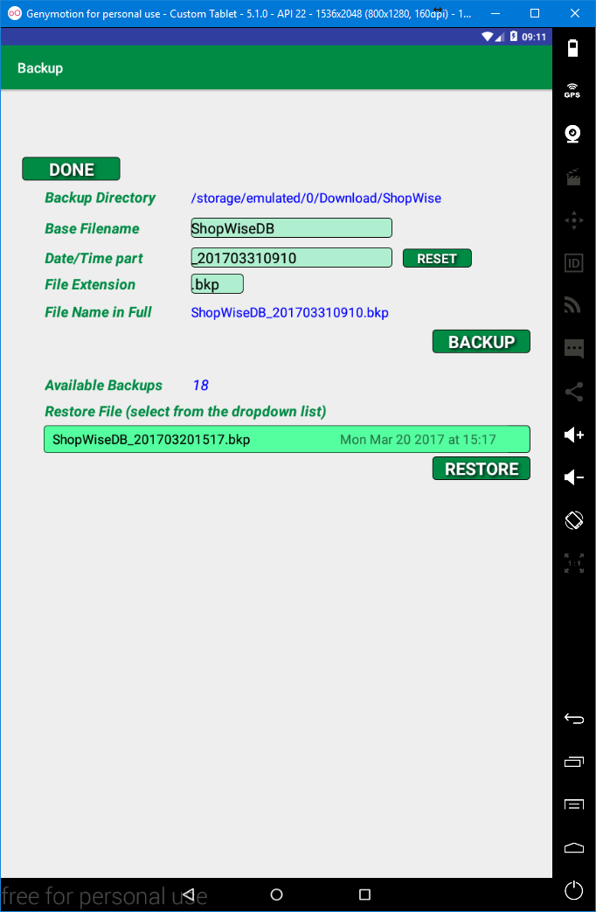

Backup facilitates the backup and restore of the **ShopWise** database. **Backups** and thus **Restore** files (backups) are stored in the **Download** directory, in a directory named **ShopWise**. The **Download** directory is chosen because **a)** most, if not all devices, should have a **Download** directory that is allocated as External Public Storage and **b)** the directory should be accessible from outside of **ShopWise**, allowing the backups to be copied and secured elsewhere or even that backups can be imported from elsewhere.

Backup and restore, by default (i.e. if no inputs are changed) saves and looks for files (in the Download/ShopWise directory) that are named **ShopWiseDB**_**YYYYMMDDHHmm.bkp,** where YYYY is the year, MM is the month in the year, DD is the day in the month and HH is the hour in the day and mm is the minute in the day.

**Backup Directory** shows the full path to where the backup files are stored. It cannot be changed.

The **Filename** is made up on three parts, the **Base Filename** (ShopWise by default), the **Date/Time Part** (the current date/time by default) and the **File Extension** (.bkp by default). To enable flexibility the parts can all be changed. However, it is recommended that these are normally not changed, with the exception of using the **RESET** button to reset the Date/Time part.

Clicking the **RESET** button will reset it to the **Date/Time Part** to the current date and time (*you could want a second backup, without using reset clicking* ***BACKUP*** *a second time would overwrite the first backup as the filename would remain unchanged*).

**Available Backups** shows how many restore files are available (note this is based upon Base Filename and File Extension, changing either may change the number available). If the number is 0 the Restore File DropDown Selector will and the Restore button will also be hidden.

**Restore File** is a DropDown selector that allows selection of a file to be used to restore the **ShopWise** database. Note, if there are no backups that match the criteria as per the **Base Filename** and **File Extension** values then the **Restore File DropDown selector** will be hidden, as will be the **RESTORE** button.

Clicking the **BACKUP** button will save the **Database**, a dialog will be displayed. Normally it will confirm that the backup was successful, otherwise it will display a message that indicates an issue.

*One issue could be that the App has insufficient permission to write to External Storage. This is more likely on Android 6.0 and later when permissions have to specifically be requested when the App runs. Backups will not work if permission is not granted (this being the ONLY permission that ShopWise uses/requests).*

Clicking the **RESTORE** button, **CAUTION**, will display a dialog allowing you to **CANCEL** or **CONTINUE** the restore using the selected **Restore File**. If **CONTINUE** is clicked the **Restore** will be attempted. An “In progress” indicator may be seen (the restore is quite fast so this may not be seen) and then a dialog will appear indicating if the restore worked or not. ***A failed restore will revert to a copy taken during the restore***. In either case clicking **OK** will result in **ShopWise** being restarted and thus the **Main display** being displayed.

# Advanced Backup/Restore

Advanced Backup/Restore is an in-depth explanation of using, altering, the **Base Filename**, the **Date/Time part** and the **File Extension** which can affect both the file name used for saving and the files listed in the **Restore File DropDown selector**.

## Base File Name

Changing the Base File will obviously change the name of the file used when making a backup via the **BACKUP** button. It may also affect the files that are listed in the **Restore File selector**. It can affect the list in two ways, it can restrict what files are shown, and perhaps more confusing it can appear to hide files due to the sorting of the list.

The files listed by the **Restore File selector** must contain the value in the **Base File Name** field anywhere within the file name.

The files listed are sorted according to their filename, so if for example, ZhopWise input into the **Base File Name** field and then a backup was taken and then the **Base File name** field were cleared. All backups (assuming they all meet the File Extension restriction) would be listed. However, the ZhopWise????? Backup would appear below normal backups starting with ShopWise (Z in the **Base File Name** would show just files with Z).

Note Base File Name is case sensitive.

## Date/Time part

The **Date/Time part** obviously affects the file name when backing up. However, it does not directly affect the restore file listed, other than that the Base File Name could be found within the **Date/Time part**, which may be a consideration.

## File Extension

The **File Extension** affects the file name when backing up. Consideration should be given to not adversely affecting other applications. For example Media managers could consider a backup with an extension of .mp3 as a music file and try to play such a file. The File Extension will only allow files that **END** with the value in the File Extension field to be listed.

All three fields can be blank which would list all files in the **DownLoad/ShopWise** directory. However, clicking the **BACKUP** button would result in the backup failing as there is no filename to save to (*actually it complains that the file is a directory*).

One use of naming backups differently could be to manage multiple databases and thus multiple Shopping Lists, perhaps allowing one device to be used by a number of people.